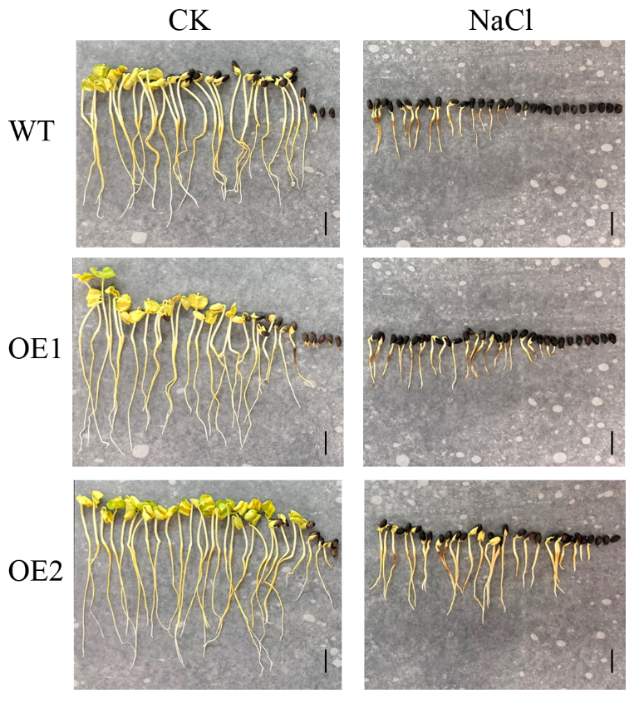
Additional file 10 Figure S5. The germination performance of transgenic lines (OE1 and OE2) and wild type line (WT) under salt treatment (NaCl) and control (CK) conditions. Bar = 1 cm.

