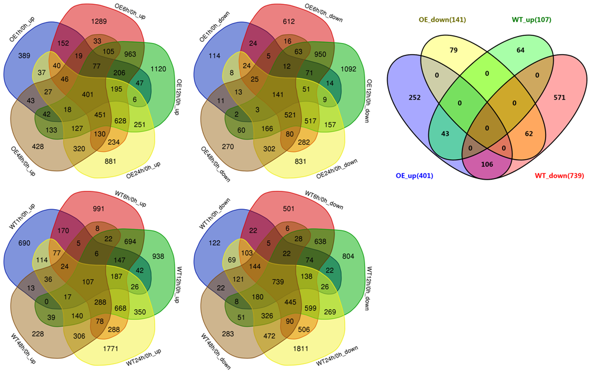
Additional file 12 Figure S7. Venn diagrams of up- and down-regulated DEGs among different salt stress time points in between OE and WT plants, identified from RNA-seq analysis.

