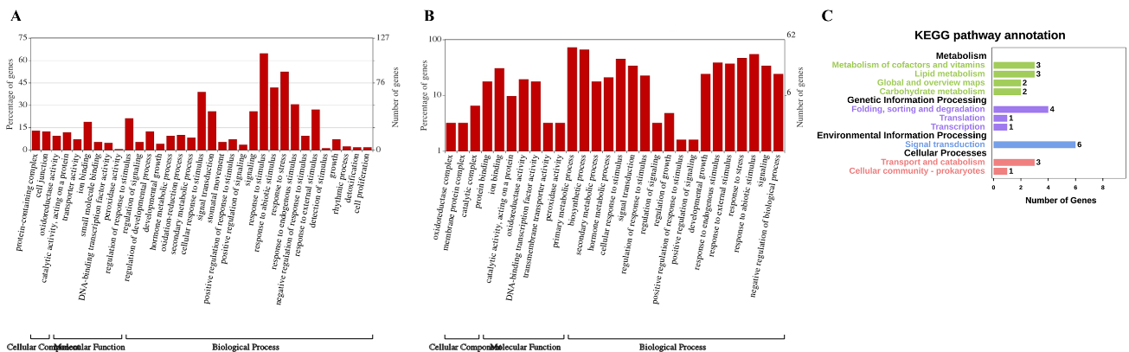
Additional file 13 Figure S8. GO-term and KEGG analysis of up- and down-regulated DEGs.
A. GO-term analysis of specific up- and down-regulated DEGs in OE plants following salt treatment. B. KEGG pathway analysis of 78 candidate DEGs.

