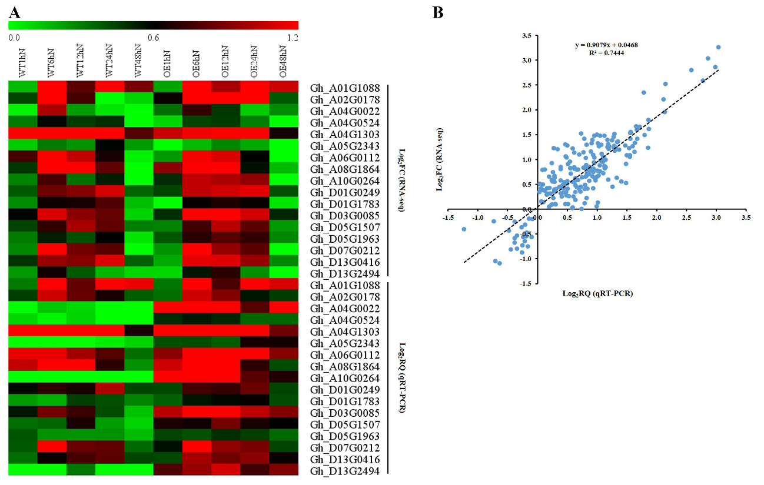
Additional file 14 Figure S9. Validation of express profiles of candidate DEGs by qRT-PCR.
A. RNA-seq analysis and qRT-PCR analysis of the co-expressed DEGs in PPI network. B. Correlation of the expression profiles between RNA-seq and qRT-PCR analysis.

