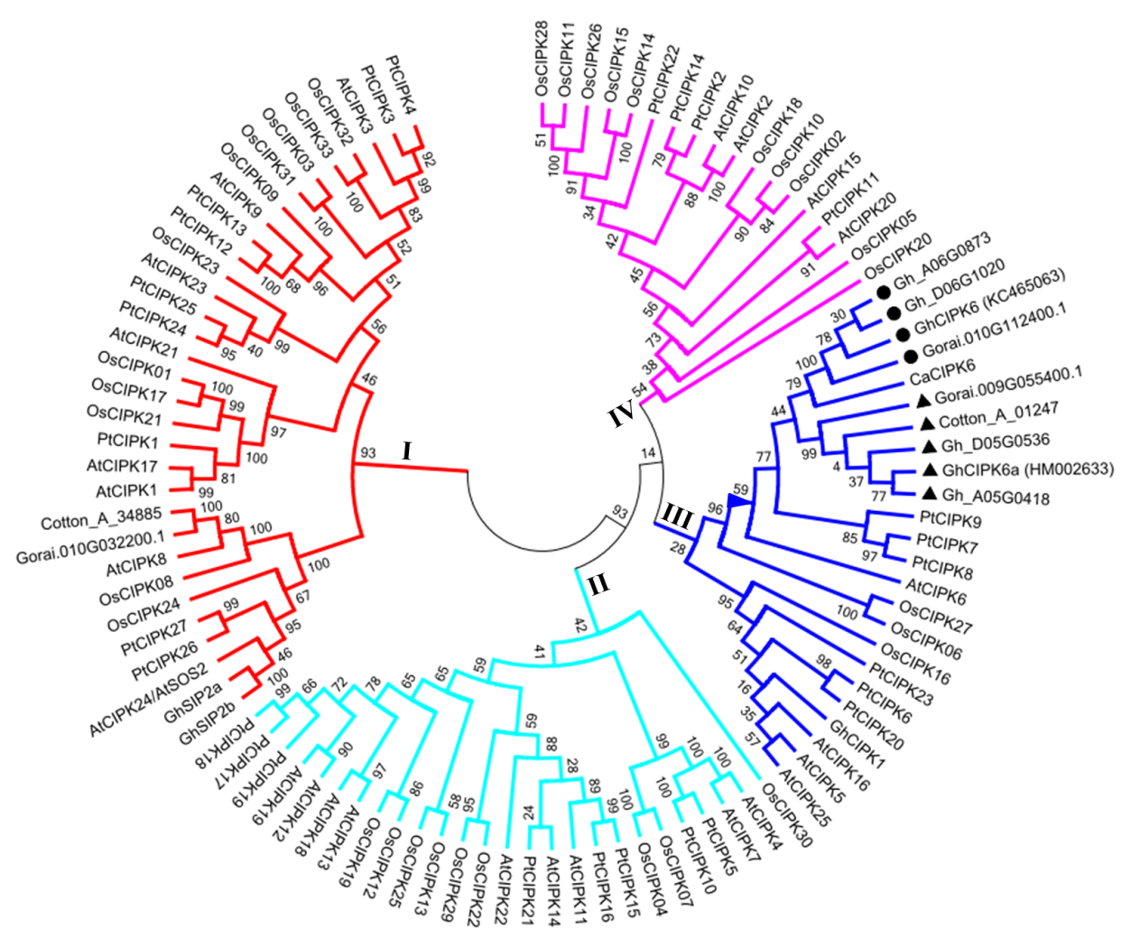
Additional file 6 Figure S1. Phylogenic analysis of GhCIPK6a and CIPK homolog proteins from other species. Full-length amino acid sequences were aligned using the integrated ClustalW and phylogenetic tree was constructed using the neighbor-joining method implemented in MEGA5.2 (1,000 bootstrap test replicates). Black triangles indicated GhCIPK6a (HM002633) and homologs from the A₂, D₅, and AD₁ genomes, respectively. Black circles indicated GhCIPK6 (KC465063), and homologs from the D₅ and AD₁ genomes, respectively. The percentage of replicate trees was shown at the branches. Different colored branches represented different groups. Proteins, located in the branch marked by a blue triangle, were chosen for multiple alignments using DNAMAN software. At, Arabidopsis thaliana; Ca, Cicer arietinum; Pt, Populus trichocarpa; Os, Oryza sativa; Gh, G. hirsutum (AD₁); Cotton_A, G. arboreum (A₂); Gorai, G. raimondii (D₅).

