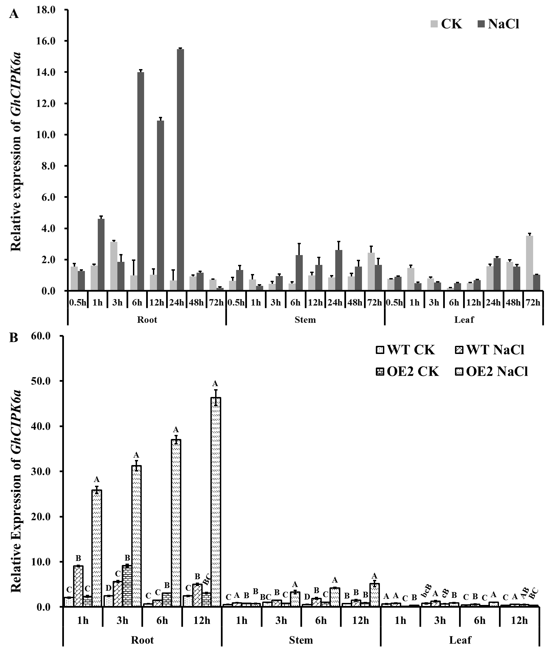
Additional file 7 Figure S2. Expression analysis of GhCIPK6a in different tissues after salt treatment. A. Expression analysis in Upland cotton cultivar ‘Zhong G5’; B. Expression profile in OE2 and wild-type lines.

