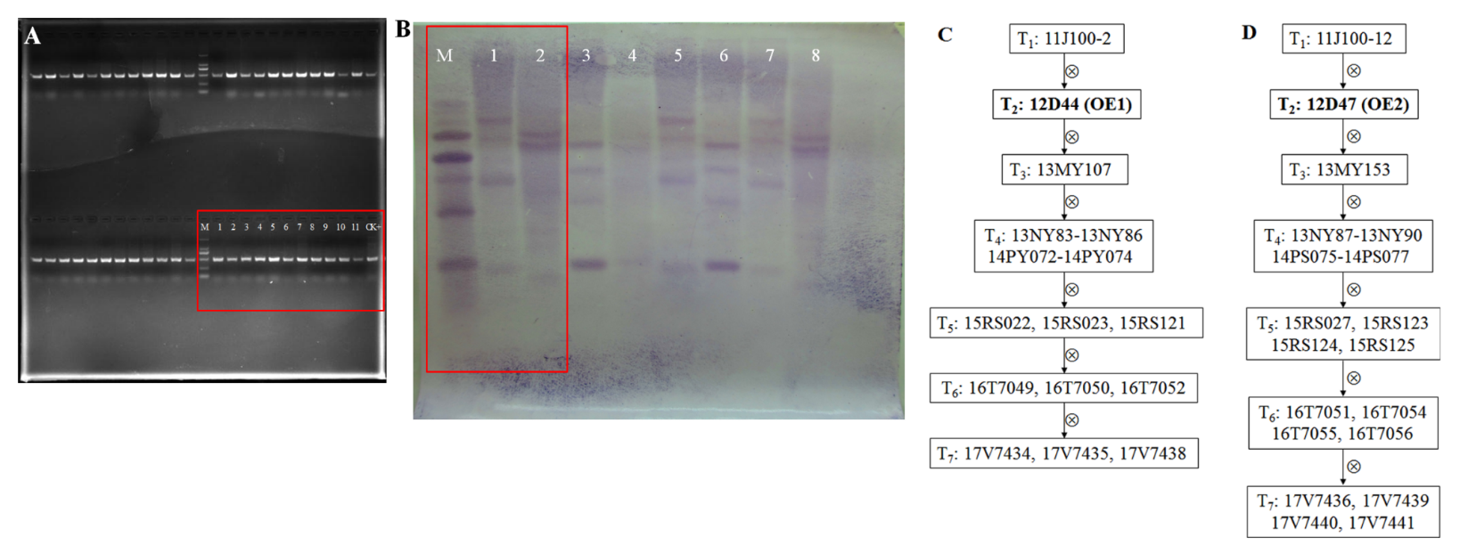
Additional file 8 Figure S3. PCR analysis and Southern blotting assay of positive transgenic plants. A. Identification of positive T₁ transgenic plants by amplifying the resistant gene NPTII. The samples marked in the red box were the positive T₁ GhCIPK6a transgenic plants. M, D2000 DNA ladder; 1-11, positive individuals: 11J100-1, 11J100-2, 11J100-7, 11J100-8, 11J100-12, 11J100-15, 11J100-21, 11J100-24, 11J100-27, 11J100-34, 11J100-35, respectively. CK+: positive control. The samples out of the red box were not involved here. B. Southern blotting assay of transgenic cotton plants using the resistance gene NPTII as the probe. In the red box: M, D2000 DNA ladder; 1, OE1 (12D44); 2, OE2 (12D47), which were the sample used in present study. 3-8, represents different individuals, which were 12D48-12D53, respectively. C and D. The genealogical diagram of OE1 (12D44) and OE2 (12D47) lines and their offspring.

