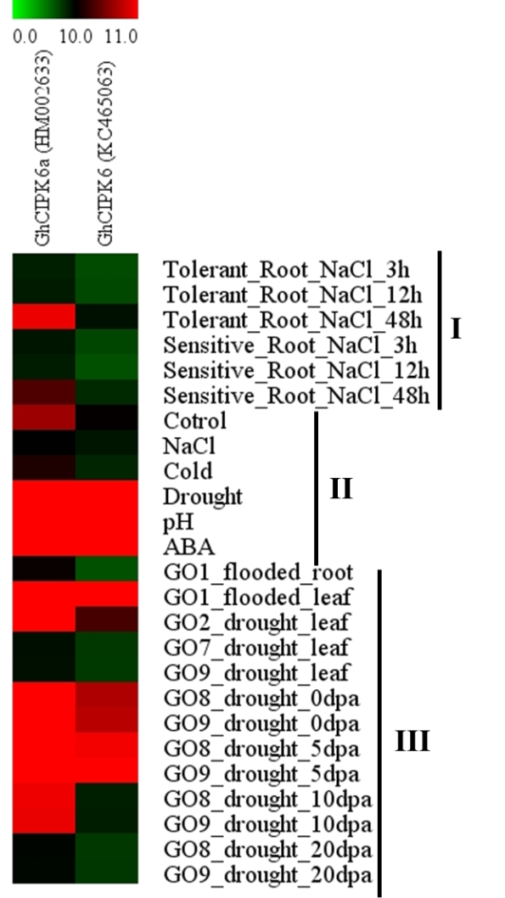
Additional file 9 Figure S4. Expression profiles of GhCIPK6s under abiotic stress using public datasets. I, public data from PLEXdb. II, GSE50770, analyzed the crosstalk between genes that are responsive to multiple abiotic stresses, including ABA, cold, drought, salinity, and alkalinity (pH) in G. hirsutum. III, Transcriptome analysis between roots of the salt-tolerant cultivar ‘Zhong 07’ and salt-sensitive cultivar ‘Zhong G5’ after 3, 12, and 48 h of 150 mmol·L⁻¹ NaCl treatment.

