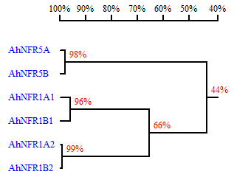

Figure S1. DNA sequence homology of AhNFR genes in peanut.

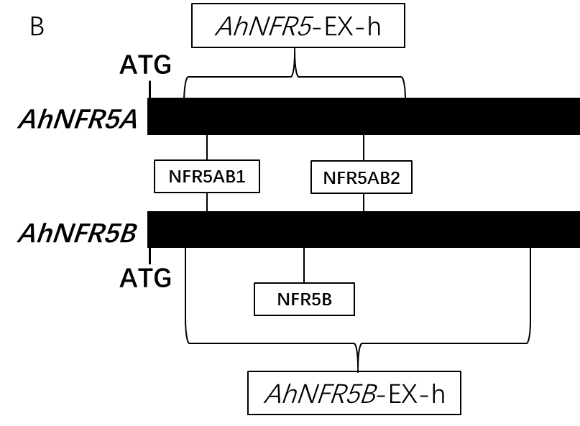
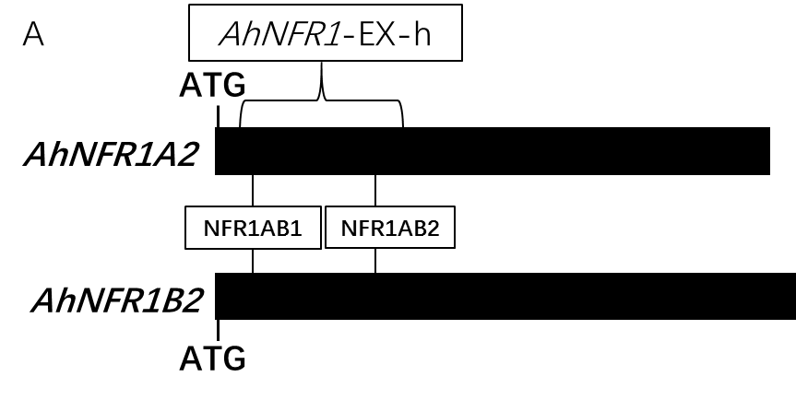

Figure S2. Schematics of gene sequence, target sites and the regions of examined PCR products of AhNFR genes in transgenic hairy roots. (A) AhNFR1A2 and AhNFR1B2 genes, (B) AhNFR5A and AhNFR5B genes. NFR1AB1, NFR1AB2, NFR5AB1, NFR5AB2, and NFR5B are gRNAs. AhNFR1-EX-h, AhNFR5-EX-h, AhNFR5B-EX-h represent amplicons covering the target sites for examining the edited gene sequence.

Figure S3. PCR products of AhNFR1 gene in transgenic hairy roots.
M: 1kb plus marker; H1-H12: transgenic AhNFR1 samples; P1-P3: hairy roots with P201G empty vector; WT: Tifrunner peanut; -: negative control.

Figure S4. PCR products of AhNFR5 gene in transgenic hairy roots.
M: DL2000 marker; F1-F10: transgenic AhNFR5 samples; P1-P3: hairy roots with P201G empty vector; WT: Tifrunner peanut; -: negative control.

Figure S5. PCR products of AhNFR5B gene in transgenic hairy roots.
M: 1kb plus marker; 5B1-5B10: transgenic AhNFR5B samples; P1-P3: hairy roots with P201G empty vector; WT: Tifrunner peanut; -: negative control.

Table S1. Percentage of different CRISPR/Cas9-caused mutations at AhNFR1A2 and AhNFR1B2 DNA sequence sites of transgenic AhNFR1 hairy roots.
Samples | Genes | Different nucleotide deletion (-) and insertion (+) events
Samples | Genes | InDel type1 | % | InDel type2 | % | InDel type3 | % | InDel type4 | % | InDel type5 | % | InDel type6 | %
H1-L | NFR1A2 | 0,0 | 39 | -2,-2 | 33 | -2,-1 | 28
 | NFR1B2 | 0,0 | 100
H2-L | NFR1A2 | 0,0 | 5 | -10,-1 | 58 | +1,-1 | 32 | +1,-5 | 5
 | NFR1B2 | 0,0 | 100
H3-L | NFR1A2 | -9,-1 | 58 | -28,-1 | 25 | -10,-1 | 8 | 0,-1 | 8
 | NFR1B2 | -28,-1 | 100
H4-L | NFR1A2 | 0,0 | 67 | -10,-1 | 33
 | NFR1B2 | +1,-1 | 100
H5-L | NFR1A2 | -10,-1 | 42 | +1,-1 | 17 | 0,-1 | 17 | -12,-1 | 8 | -13,-1 | 8 | -22,-1 | 8
 | NFR1B2 | -10,-1 | 25 | 0,-1 | 25 | -7,-1 | 13 | -3,-1 | 13 | +1,-1 | 13 | +3,-1 | 13
H6-L | NFR1A2 | -2,-1 | 33 | -38,-1 | 33 | -10,-1 | 11 | -12,-1 | 11 | -7,-1 | 11
 | NFR1B2 | -28,-9 | 27 | -7,-1 | 18 | -6,0 | 9 | -7,-12 | 9 | 0,-3 | 9 | -1/-13/-37,0 | 27
H7-L | NFR1A2 | -7,-1 | 27 | 0,0 | 27 | +1,-5 | 9 | +1,-1 | 9 | 0,-1 | 9 | -9/-2,-1 | 18
 | NFR1B2 | 0,0 | 33 | -2,-1 | 44 | -15,0 | 22
H8-L | NFR1A2 | -4,-6 | 100
 | NFR1B2 | -41,-6 | 82 | -41,0 | 12 | -13,-1 | 6
H9-L | NFR1A2 | N.A.
 | NFR1B2 | -4,-6 | 45 | -4,-3 | 55
H10-L | NFR1A2 | -9,-1 | 11 | -3,-72 | 11 | -3/0,+1 | 22 | +1,-57 | 11 | -10/0,-1 | 11 | -3/-7,-2 | 22
 | NFR1B2 | -4,-1 | 73 | +1,-5 | 9 | 0,-57 | 9 | -4,-13 | 9
H1-L~H10-L: alignment of genomic sequences cloned from the long PCR products using DNA samples H1~H10 of transgenic AhNFR1 hairy roots as templates. InDel type shows the type of insertion (+), or deletion (-). The number following the + or - are the inserted (+) or deleted (-) number of nucleotides. ‘%’ represents percentage of the type of InDel among all edit events detected in the sample.

Table S2. Percentage of different CRISPR/Cas9-caused mutations at AhNFR5A and AhNFR5B DNA sequence sites of transgenic AhNFR5 hairy roots.
Samples | Genes | Different nucleotide deletion (-) and insertion (+) events
Samples | Genes | InDel type1 | % | InDel type2 | % | InDel type3 | % | InDel type4 | %
F1 | NFR5A | -5,-4 | 38 | -5,-5 | 25 | -5,0 | 25 | -1,-5 | 13
F1 | NFR5B | -3,0 | 25 | -11,-7/-3 | 33 | -3,-3/-8 | 25 | 0,+1 | 17
F2 | NFR5A | 0,0 | 50 | -2,-7 | 17 | -4,-7 | 17 | -1,-8 | 17
F2 | NFR5B | 0,0 | 50 | +1,-3 | 25 | -1,-3 | 13 | -1,-7 | 13
F3 | NFR5A | -7,-2 | 58 | +1,0 | 25 | +1,-2 | 8 | -1,0 | 8
F3 | NFR5B | -5,0 | 86 | +1,-7 | 14
F4 | NFR5A | 0,0 | 100
F4 | NFR5B | 0,0 | 83 | -5,0 | 17
F5 | NFR5A | 0,0 | 67 | -5,0 | 17 | +1,0 | 17
F5 | NFR5B | 0,0 | 21 | -4,-13 | 64 | -5,0 | 7 | 0,-13 | 7
F6-L | NFR5A | -1,0 | 100
F6-L | NFR5B | N.A.
F6-S | NFR5A | -736 | 100
F6-S | NFR5B | N.A.
F7 | NFR5A | 0,0 | 100
F7 | NFR5B | 0,0 | 100
F8 | NFR5A | 0,0 | 20 | -1,0 | 80
F8 | NFR5B | 0,0 | 80 | -16,0 | 20
F9 | NFR5A | +1,0 | 80 | -34,-5 | 20
F9 | NFR5B | -3,-2 | 30 | -4,-2 | 30 | +1,0 | 20 | -4,-50 | 20
F10 | NFR5A | 0,0 | 100
F10 | NFR5B | 0,0 | 100
F1~F10: alignment of genomic sequences cloned from the PCR products using DNA samples F1~F10 of transgenic AhNFR5 hairy roots as templates (F6-L/F6-S represent clones are from the long or short PCR products respectively.). InDel type shows the type of insertion (+) or deletion (-). The numbers following the + or - are the inserted (+) or deleted (-) number of nucleotides. ‘%’ represents percentage of the type of InDel among all edit events detected in the sample.

Table S3. The primers of AhNFR genes.
 | Forward primer | Reverse primer
AhNFR1A2 | ATGGAACCCAGACATAGG | CTATCTTCCGGACATGAG
AhNFR1B2 | ATGGAACCCAGATATGGG | CTATCTTCCGGACATGAG
AhNFR5A | ATGGCTTTCTTTCTACCCTCT | TTAACGTGCTGCTATGGGAGT
AhNFR5B | ATGGCTTTCTTTCTACCC | TTAACGTGCTGCTATGGGA
Table S4. The primers of q-PCR of AhNFR genes.
 | Forward primer | Reverse primer
AhNFR1A1-q-PCR | ACAGAGGCAGATCCGAAGCG | GAAGGAAGCAATGTCCCAAT
AhNFR1B1-q-PCR | AGTTTGCCCTGGTTTCTGC | CAAGATTCTATTTCCTCCGTCC
AhNFR1A2-q-PCR | GTTTGTATCTGTGCTCTTGCAG | AGTTGACTATGTCGTTTGGGTC
AhNFR1B2-q-PCR | TCCCTAACACTGGAACCCTT | CACTCTGATTCTTCGCCACA
AhNFR5A-q-PCR | CTCATTGAGTTGCTGACAGGC | CCATCTTCTCAGACACTCCTCC
AhNFR5B-q-PCR | ATGTTCTCCATCACCAGCATC | TGTTCCACAGGAAGAAGGTGA

Table S5. Primers for constructing and examining CRISPR/Cas9:AhNFR vectors.
 | Forward primer | Reverse primer
Primer-EX-V | CCCACATCGTCTGAAACA | GTCATCCACCTTAGCCATC
SpeI_MtU6-Forward | CGTGCTCCACCATGTTGGGAATGCCTATCTTATATGATCAATGAGG
MtU6-Reverse | AAGCCTACTGGTTCGCTTGAAG
Scaffold- Forward | GTTTTAGAGCTAGAAATAGCAAGTT
ApaI_Scaffold- Reverse | GTGCTCCACCATGTTGGGCCAAAAAAAGCACCGACTCGGTG
UNS1_Scaffold- Reverse | GAGAATGGATGCGAGTAATGAAAAAAAGCACCGACTCGGTG
UNS1_MtU6- Forward | CATTACTCGCATCCATTCTCATGCCTATCTTATATGATCAATGAGG

Table S6. Primers for amplifying the target genes of transgenic AhNFR hairy roots.
 | Forward primer | Reverse primer
AhNFR1-EX-h | TTGCTGCTGGGTTGCGTTCTTTA | GAGCCTTGGTTGAAATTGACAGA
AhNFR5-EX-h | TTCTTGAGCCTTTCTAACA | AAGGGACCCGTTATCAGC
AhNFR5B-EX-h | ACATACATCGCTAAATCTCCAAAC | CATCTTCTCAGACATTCCTCCTT

