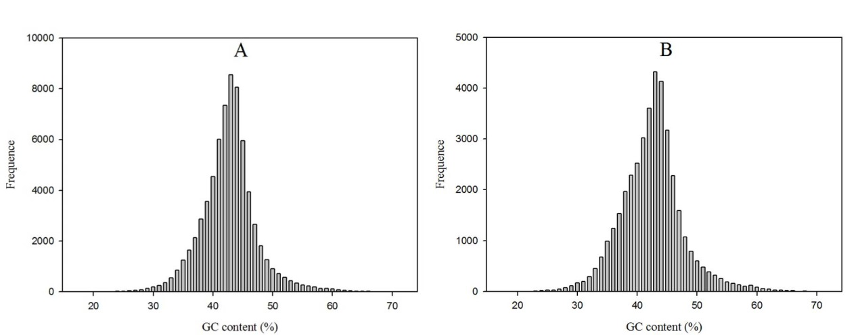
FIGURE S3 | GC content distributions of assembled transcripts and genes.
A, GC content distributions of transcripts; B, GC content distributions of genes.

