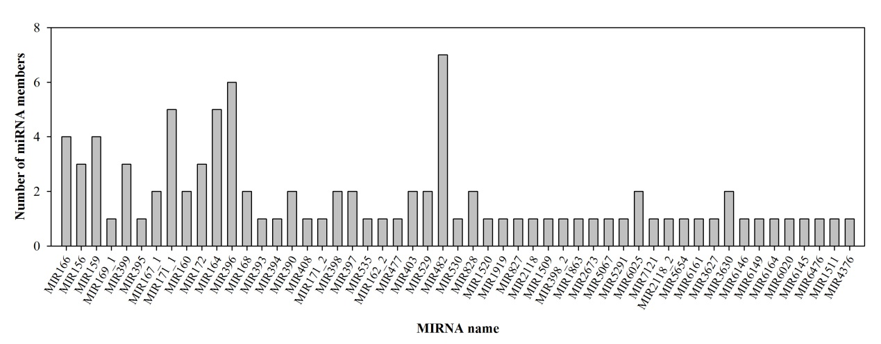
FIGURE S4 | Number of miRNA family members in pitaya pulp.

