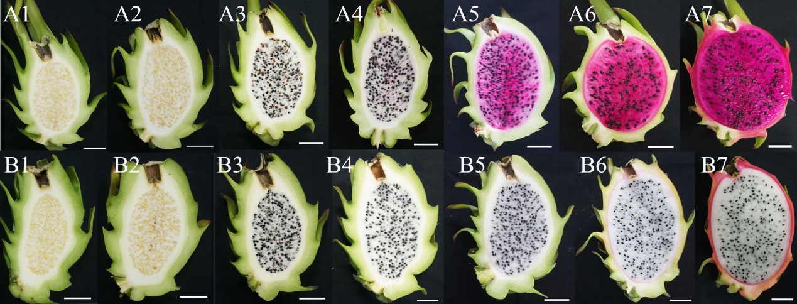
FIGURE S7 | Different fruit developmental stages of Guanhuahong (A) and Guanhuabai (B) pitayas.
A1 and B1, 13 d; A2 and B2, 16 d; A3 and B3, 19 d; A4 and B4, 23 d; A5 and B5, 25 d; A6 and B6, 27 d; A7 and B7, 29 d. Bar=2.0 cm.

