a
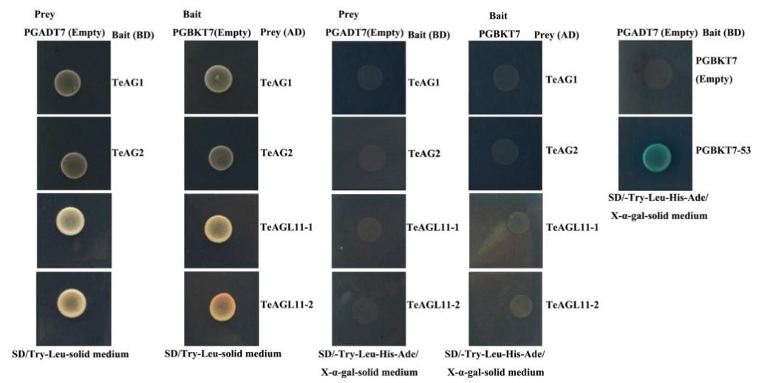
b
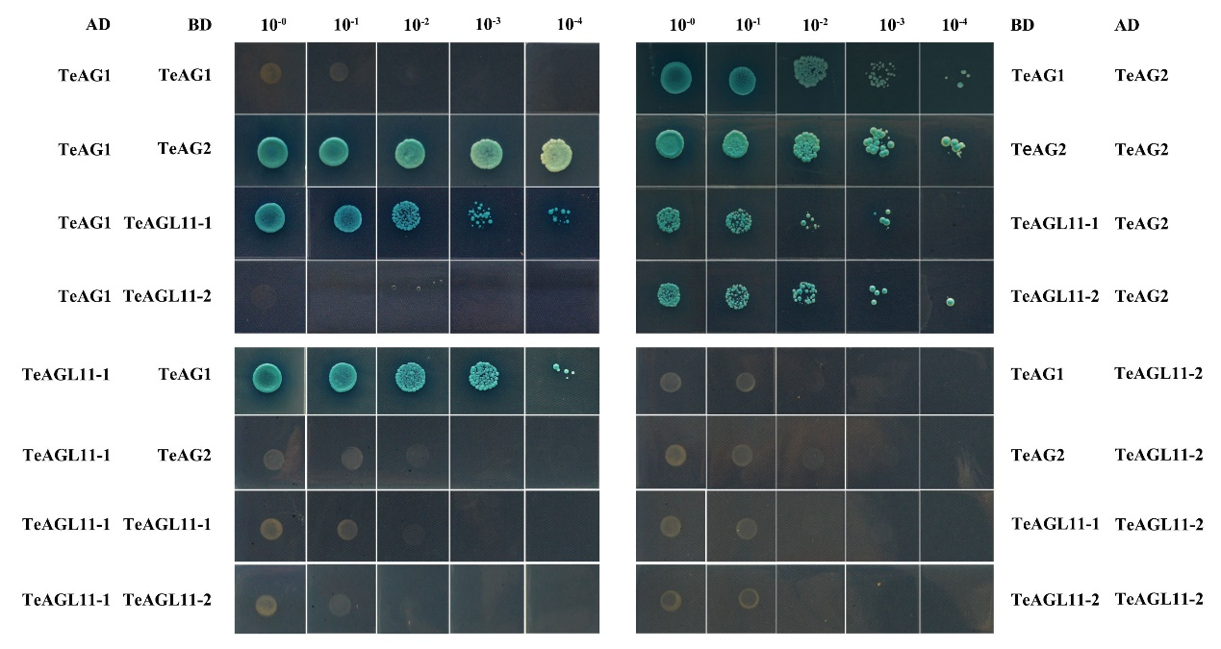
Fig. S2. Interactions of TeAG and TeAGL11 proteins of marigold by yeast two-hybrid assays. (a) Assession of Self-activation and autoaction of AD and BD constructs. (b)Ten-fold serial dilutions from 10⁻¹ to 10⁻⁴ of each culture were spotted on the selected SD -Leu/-Trp/-His/-Ade plates with X-α-gal.

