SUPPLEMENTARY INFORMATION

Stalk architecture, cell wall composition, and QTL underlying high stalk flexibility for improved lodging resistance in maize

Xiaqing Wang^{1,3}, Zi Shi^{1,3}, Ruyang Zhang¹, Xuan Sun¹, Jidong Wang¹, Shuai Wang¹, Ying Zhang², Yanxin Zhao¹, Aiguo Su¹, Chunhui Li¹, Ronghuan Wang¹, Yunxia Zhang¹, Shuaishuai Wang¹, Yuandong Wang¹, Wei Song^{1*}, Jiuran Zhao^{1*}

¹Beijing Key Laboratory of Maize DNA Fingerprinting and Molecular Breeding, Maize Research Center, Beijing Academy of Agriculture & Forestry Sciences (BAAFS), Shuguang Garden Middle Road No. 9, Haidian District, Beijing 100097, China.
²Beijing Key Lab of Digital Plant, Beijing Research Center for Information Technology in Agriculture, Beijing Academy of Agriculture and Forestry Sciences (BAAFS), Shuguang Garden Middle Road No. 11, Haidian District, Beijing 100097, China.
³These authors contributed equally to this work.

*Corresponding authors:
Wei Song, Tel: (+86) 01051503983， E-mail: songwei1007@126.com
Jiuran Zhao, Tel: (+86) 01051503936，E-mail: maizezhao@126.com

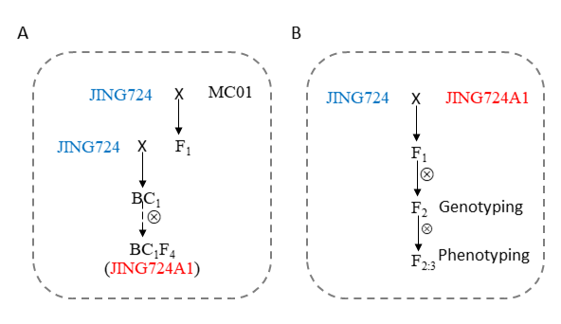
Fig. S1 The construction process of JING724A1 and the F_{2:3} population. (A) The development of JING724A1. (B) The construction of the F_{2:3} population using JING724 and JING724A1.

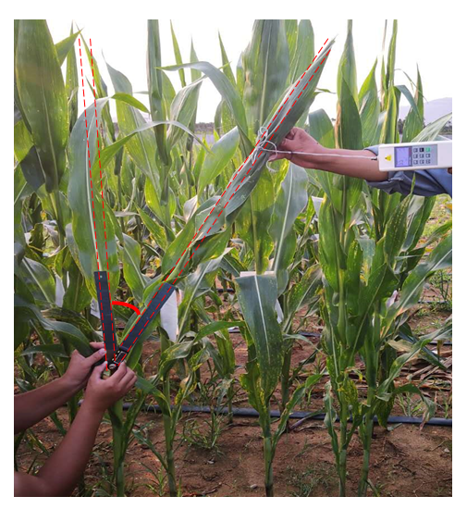
Fig. S2 Measurement of stalk fracture angle.

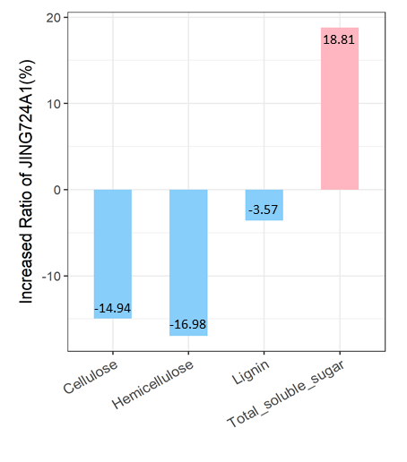
Fig. S3 The increased ratio of specific cell wall components in JING724A1 compared to JING724.

Table S1 Overview of sequencing results.
Sample | Clean reads | High quality  clean data (bp) | Q30 (%) | GC (%) | Properly mapped (%) | Average depth
H-pool | 505,846,216 | 75,588,837,622 | 91.16% | 47.82% | 98.71% | 29.95X
L-pool | 454,234,782 | 67,921,209,847 | 90.73% | 47.08% | 98.36% | 26.79X
J724 | 357,343,896 | 53,463,500,489 | 90.81% | 46.98% | 98.55% | 21.11X
J724A1 | 311,254,540 | 46,576,669,927 | 90.37% | 47.64% | 98.46% | 18.30X

Table S2 Summary of SNPs and InDels for the parents and pools.
Sample | SNPs | InDels
H-pool | 5,760,595 | 710,352
L-pool | 5,725,864 | 707,044
JING724 | 5,277,813 | 652,925
JING724A1 | 5,158,743 | 636,008

Table S3 Four KASP makers and the significance with the stalk fracture angle.
Marker | Chr | Location | Ref | Mut | p-value
KA_1 | 3 | 16,414,171 | C | T | 0.02
KA_2 | 3 | 16,468,608 | C | G | 0.02
KA_3 | 3 | 16,736,281 | T | G | 0.03
KA_4 | 3 | 17,544,848 | T | G | 0.04

Table S4 The expression level of 12 genes.
Gene_ID | Chr | Start | End | log₂FC
Zm00001d039769 | 3 | 14,333,996 | 14,339,635 | -1.28
Zm00001d039824 | 3 | 15,918,978 | 15,922,548 | 1.71
Zm00001d039825 | 3 | 15,958,238 | 15,958,636 | -2.82
Zm00001d039827 | 3 | 15,992,310 | 15,992,768 | 3.03
Zm00001d039837 | 3 | 16,287,892 | 16,290,203 | -1.07
Zm00001d039848 | 3 | 16,535,244 | 16,539,074 | 1.31
Zm00001d039859 | 3 | 16,955,374 | 16,956,401 | 2.14
Zm00001d039880 | 3 | 17,453,267 | 17,454,450 | -4.9
Zm00001d039882 | 3 | 17,546,111 | 17,550,377 | 1.9
Zm00001d039891 | 3 | 18,182,217 | 18,183,569 | -4.73
Zm00001d039893 | 3 | 18,371,543 | 18,374,234 | 1.17
Zm00001d039913 | 3 | 19,194,748 | 19,210,804 | -1.65

Table S5 The important SNPs and InDels for the two candidate genes.
Gene | Chr | Start | End | Ref | Mut | Type | ΔSNP-index | Function type | Function effect*
Zm00001d039769 | 3 | 14,337,550 | 14,337,550 | G | A | SNP | 0.31 | nonsynonymous | T005:exon3:c.G280A:p.G94S
Zm00001d039769 | 3 | 14,337,614 | 14,337,614 | T | C | SNP | 0.22 | nonsynonymous | T005:exon3:c.T344C:p.V115A
Zm00001d039769 | 3 | 14,337,635 | 14,337,635 | G | T | SNP | 0.35 | nonsynonymous | T005:exon3:c.G365T:p.R122I
Zm00001d039769 | 3 | 14,337,643 | 14,337,643 | G | T | SNP | 0.30 | nonsynonymous | T005:exon3:c.G373T:p.A125S
Zm00001d039769 | 3 | 14,337,719 | 14,337,719 | G | A | SNP | 0.42 | nonsynonymous | T005:exon3:c.G449A:p.S150N
Zm00001d039769 | 3 | 14,337,754 | 14,337,754 | G | A | SNP | 0.53 | nonsynonymous | T005:exon3:c.G484A:p.A162T
Zm00001d039769 | 3 | 14,337,817 | 14,337,817 | A | G | SNP | 0.56 | nonsynonymous | T005:exon3:c.A547G:p.I183V
Zm00001d039769 | 3 | 14,338,006 | 14,338,006 | T | G | SNP | 0.13 | nonsynonymous | T005:exon3:c.T736G:p.L246V
Zm00001d039769 | 3 | 14,338,239 | 14,338,239 | A | T | SNP | 0.26 | nonsynonymous | T005:exon4:c.A796T:p.R266W
Zm00001d039769 | 3 | 14,338,307 | 14,338,307 | C | G | SNP | -0.03 | nonsynonymous | T005:exon4:c.C864G:p.H288Q
Zm00001d039769 | 3 | 14,338,476 | 14,338,476 | - | CCT | Insertion | - | nonframeshift insertion | T005:exon4:c.1033_1034insCCT:p.T345delinsTS
Zm00001d039769 | 3 | 14,338,719 | 14,338,719 | G | T | SNP | 0.16 | nonsynonymous | T005:exon4:c.G1276T:p.V426F
Zm00001d039769 | 3 | 14,339,220 | 14,339,220 | G | C | SNP | 0.24 | nonsynonymous | T005:exon6:c.G1551C:p.E517D
Zm00001d039913 | 3 | 19,204,088 | 19,204,088 | G | T | SNP | 0.48 | nonsynonymous | T001:exon2:c.G235T:p.V79F
Zm00001d039913 | 3 | 19,204,128 | 19,204,128 | G | T | SNP | 0.46 | nonsynonymous | T001:exon2:c.G275T:p.R92L
Zm00001d039913 | 3 | 19,204,134 | 19,204,134 | G | A | SNP | 0.44 | nonsynonymous | T001:exon2:c.G281A:p.C94Y
Zm00001d039913 | 3 | 19,204,178 | 19,204,178 | - | CATGCAGTTGTTATGAGTAAATATAAG | Insertion | - | stopgain | T001:exon2:c.325_326ins,p.S109delinsSCSCYEX
Zm00001d039913 | 3 | 19,209,490 | 19,209,490 | G | A | SNP | 0.31 | nonsynonymous | T002:exon3:c.G304A:p.D102N
Zm00001d039913 | 3 | 19,209,493 | 19,209,493 | G | A | SNP | 0.40 | nonsynonymous | T002:exon3:c.G307A:p.E103K
Zm00001d039913 | 3 | 19,210,504 | 19,210,504 | - | CGG | Insertion | - | nonframeshift insertion | T002:exon5:c.517_518insCGG:p.T173delinsTA
* Note: Transcript: SNP location: coding sequence variation and its position: amino acid conversion and its position

Table S6 Sequences of two KASP markers for the two candidate genes.
ID | Gene | SNP | Primer_AlleleFAM | Primer_AlleleHEX | Primer_Common | Allele_FAM | Allele_HEX
BA_29 | Zm00001d039769 | Chr3:14338239 | GAAGGTGACCAAGTTCATGCTCCAACCACAGGATAGTAAGCCCT | GAAGGTCGGAGTCAACGGATTCCAACCACAGGATAGTAAGCCCA | CAGGTATGACTAGCAGGGTCCCAA | A | T
BA_19 | Zm00001d039913 | Chr3:19204088 | GAAGGTGACCAAGTTCATGCTATTCCTGTGTTTGAATGGATAAGTGAC | GAAGGTCGGAGTCAACGGATTAAATTCCTGTGTTTGAATGGATAAGTGAA | CATTCTATGACCTACATGAAACTAGGCAA | G | T

