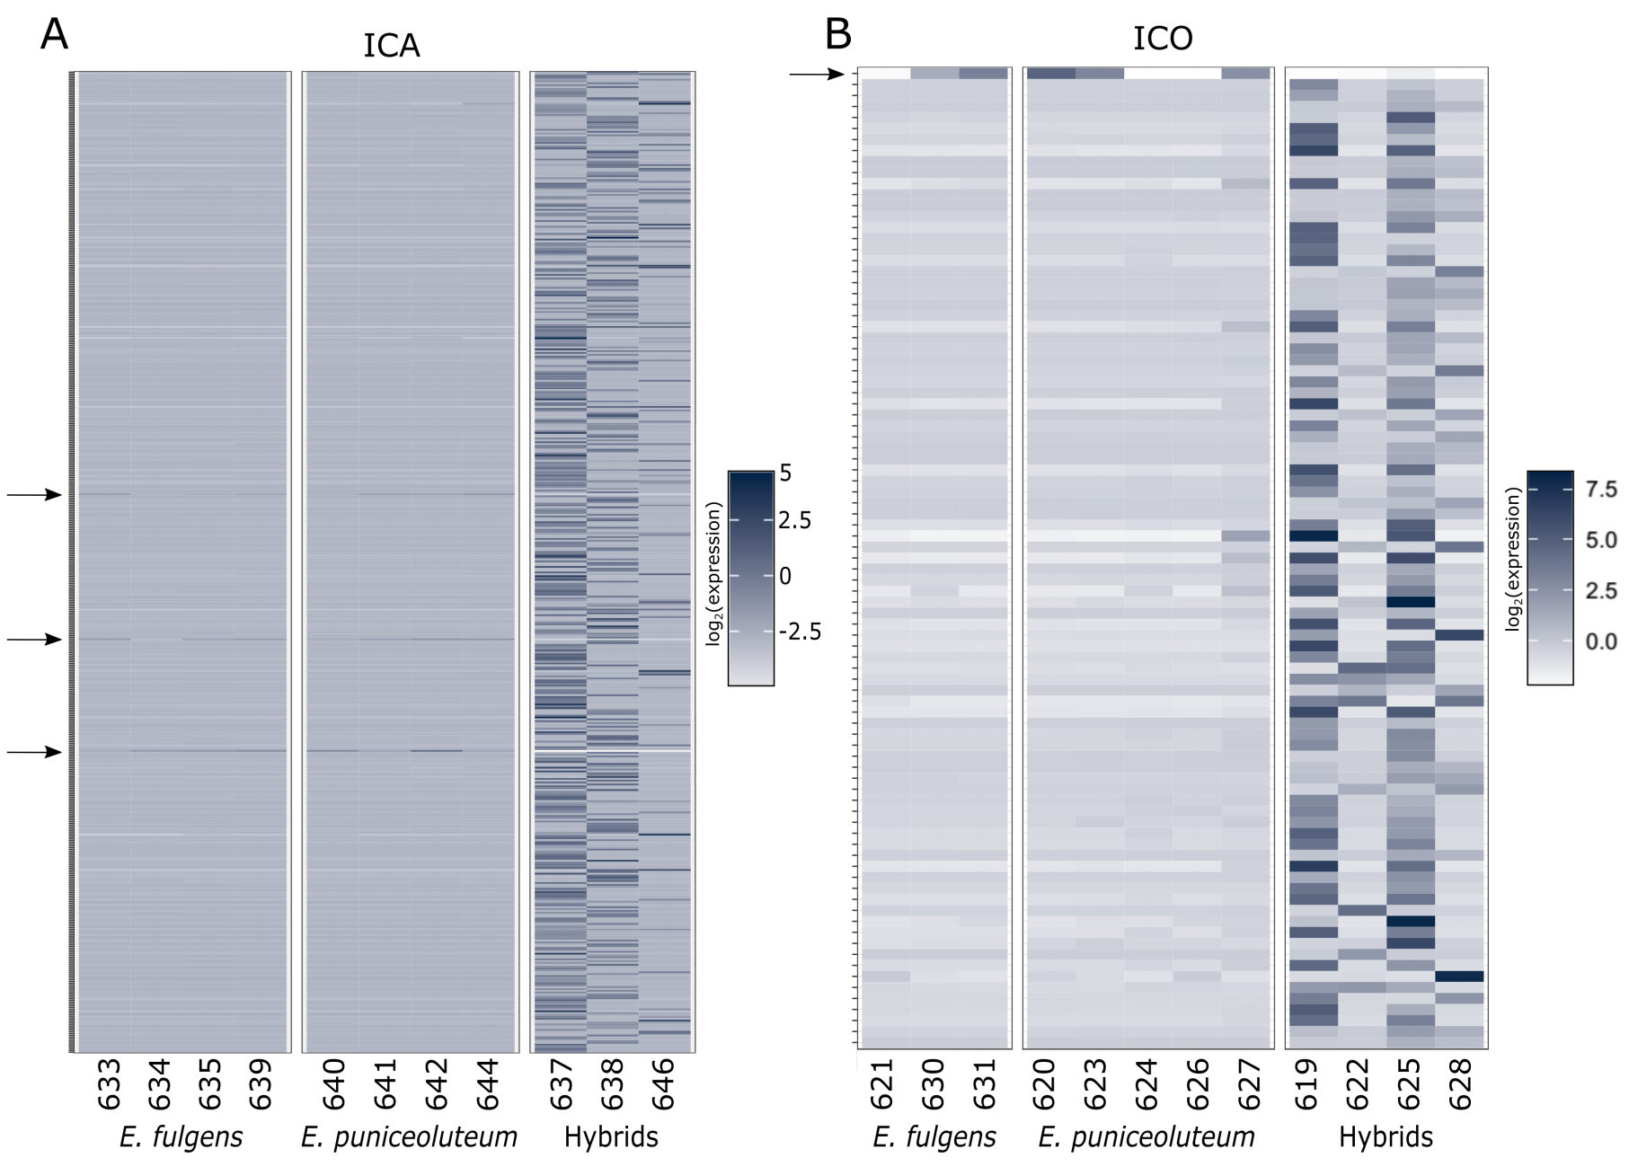
Figure S1. Heatmaps showing the expression of 528 and 89 transgressive genes in hybrids relative to parental species Epidendrum fulgens and E. puniceoluteum in ICA (A) and ICO (B) hybrid zones. Each row represents a single transcript and the colors from light gray to black denote expression levels (log₂ transformed centered values of FPKM). Transgressive transcripts are up regulated in hybrids, with exception of three down regulated transcripts in ICA and a single down-regulated transcript in ICO (marked with arrows).

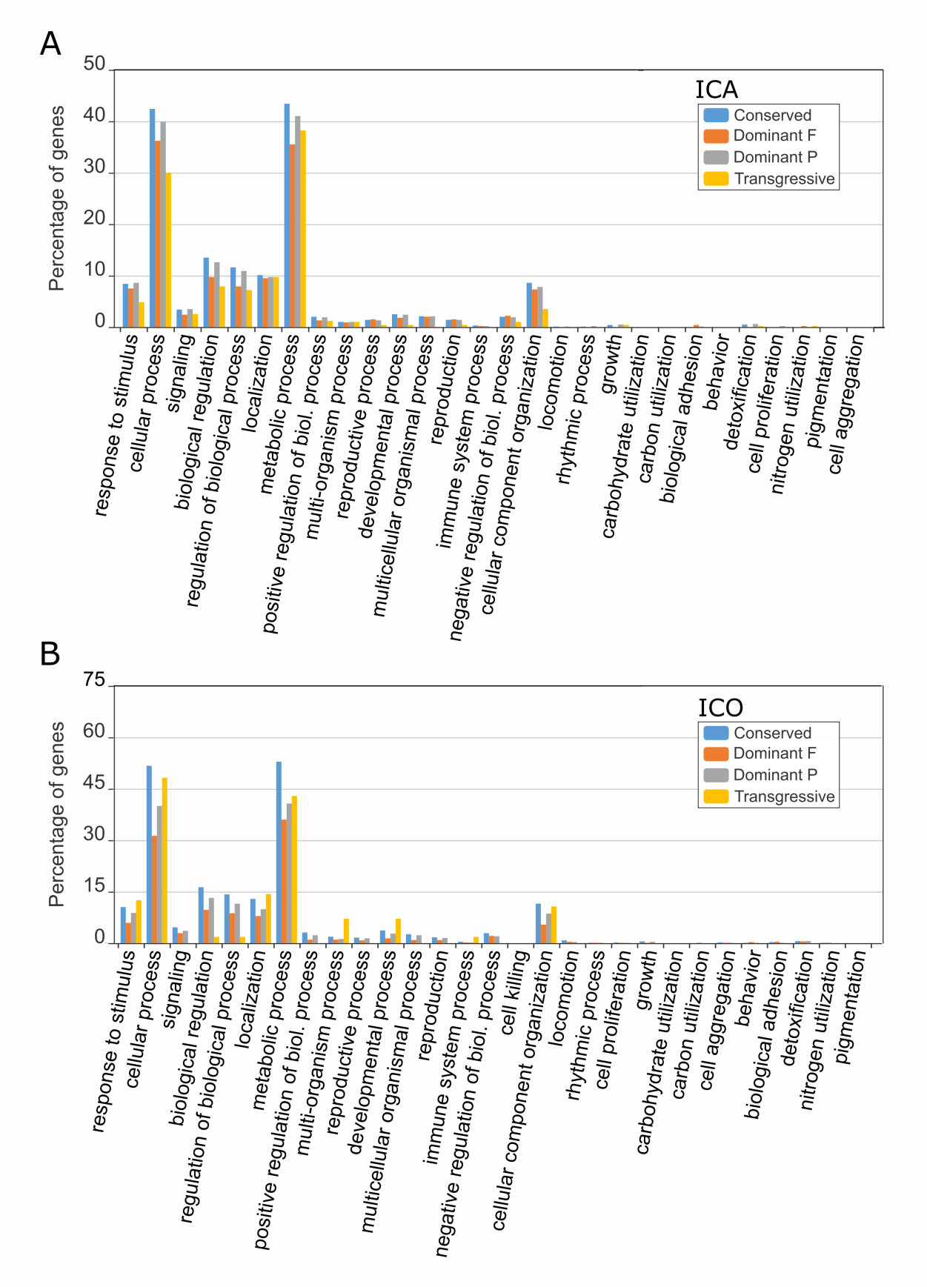
Figure S2. Categorized gene ontology (GO) terms associated with conserved, additive, dominant (either Epidendrum fulgens, F, or E. puniceoluteum, P), and transgressive modes of inheritance in hybrids from sympatric zones ICA (A) and ICO (B). GO terms are summarized into molecular functions and biological process categories according to WEGO.
Table S1. Number of sampled individuals (N) of E. fulgens, E. puniceolutem, and hybrids for each sympatric and allopatric population. Vouchers for each species and location are deposited in the Herbarium of the Instituto de Botânica de São Paulo (SP), Brazil.
Id | Species | Locality | Coordinates (lat-long) |  | Voucher | N_{RNA} | N_{SOIL}
ICA | E. fulgens | Ilha do Cardoso - SP | -25.0657 | -47.9096 | F. Pinheiro 632 | 4 | 3
ICA | E. puniceoluteum | Ilha do Cardoso - SP | -25.0657 | -47.9096 | F. Pinheiro 529 | 4 | 3
ICA | Hybrids | Ilha do Cardoso - SP | -25.0657 | -47.9096 | F. Pinheiro 655 | 3 | 3
ICO | E. fulgens | Ilha Comprida - SP | -24.8583 | -47.7087 | F. Pinheiro 653 | 3 | 3
ICO | E. puniceoluteum | Ilha Comprida - SP | -24.8583 | -47.7087 | F. Pinheiro 528 | 5 | 4
ICO | Hybrids | Ilha Comprida - SP | -24.8583 | -47.7087 | F. Pinheiro 654 | 4 | 3
BER | E. fulgens | Bertioga - SP | -23.7786 | -45.9590 | F. Pinheiro 616 | 4 | -
PPR | E. puniceoluteum | Pontal do Paraná - PR | -25.6332 | -48.4259 | F. Pinheiro 621 | 5 | -
Total |  |  |  |  |  | 32 | 19

Table S2. Coefficients of linear discriminants of a LDA using soil data from sites of Epidendrum fulgens, E. puniceoluteum and their hybrids in ICA and ICO. Values hilighted in bold correspond to variables more correlated to the first and second linear discriminant axis (LD1 and LD2, respectively).
Soil variable | ICA |  | ICO
Soil variable | LD1 | LD2 | LD1 | LD2
pH | -3.068 | -0.856 | -0.740 | 0.193
Organic matter (OM) | 1.424 | 0.926 | -0.082 | 0.231
Phosphorus (P) | -0.268 | 0.660 | 0.193 | -0.947
Sulfur (S) | 5.326 | -0.030 | -0.534 | -1.207
Potassium (K) | 3.000 | -0.491 | 0.786 | -0.038
Calcium (Ca) | -3.418 | 0.897 | -0.377 | -0.432
Magnesium (Mg) | 1.537 | 0.798 | -0.059 | 0.911
Aluminium (Al) |  |  | 0.113 | -0.272
Sodium (Na) | -0.829 | 1.592 | -0.084 | -0.107
Potential acidity (PA) | 0.278 | -0.978 | 0.115 | 0.550
Sum of bases (SB) | -0.800 | 0.236 | -0.118 | 0.231
Cation Exchange Capacity (CEC) | 0.850 | -0.960 | -0.001 | 0.336
% Base Saturation (BSP) | -2.504 | 0.182 | -0.307 | 0.782
% Aluminium Saturation (ASP) | 2.920 | 1.040 | 0.786 | -0.171

Table S3. Correlations between soil variables and the first principal component (PC1) of PCAs using soil data for sites of Epidendrum fulgens, E. puniceoluteum and their hybrids in ICA and ICO.
Soil variable | ICA | ICO
pH | -0.300 | 0.334
Organic matter (OM) | -0.290 | -0.356
Phosphorus (P) | -0.276 | -0.119
Sulfur (S) | -0.258 | -0.033
Potassium (K) | -0.270 | -0.216
Calcium (Ca) | -0.325 | 0.093
Magnesium (Mg) | -0.326 | -0.170
Aluminium (Al) | - | -0.294
Sodium (Na) | -0.223 | -0.350
Potential acidity (PA) | -0.035 | -0.383
Sum of bases (SB) | -0.325 | -0.068
Cation Exchange Capacity (CEC) | -0.316 | -0.373
% Base Saturation (BSP) | -0.310 | 0.301
% Aluminium Saturation (ASP) | 0.212 | -0.268

Table S4. RNA sequencing summary information for individuals of Epidendrum fulgens, E. puniceoluteum, and hybrids. GC = guanine-cytosine content; PHRED scores Q20 = accuracy of a base call of 99% and Q30 = accuracy of a base call of 99.9%.
Id | Species | Locality | Base pairs | Raw reads | GC (%) | Q20 (%) | Q30 (%)
595F | E. fulgens | BER | 1.48E+10 | 146,116,152 | 49.9 | 98.95 | 98.14
596F | E. fulgens | BER | 1.39E+10 | 137,645,954 | 49.37 | 98.99 | 98.22
597F | E. fulgens | BER | 1.30E+10 | 129,124,264 | 49.6 | 98.94 | 98.12
598F | E. fulgens | BER | 1.07E+10 | 105,734,802 | 49.51 | 98.92 | 98.06
619H | Hybrid | ICO | 1.38E+10 | 136,939,166 | 49.39 | 99.01 | 98.24
620P | E. puniceoluteum | ICO | 1.33E+10 | 131,329,984 | 49.44 | 98.99 | 98.2
621F | E. fulgens | ICO | 1.27E+10 | 125,888,854 | 49.38 | 99.01 | 98.23
622H | Hybrid | ICO | 1.28E+10 | 126,419,460 | 49.15 | 98.99 | 98.22
623P | E. puniceoluteum | ICO | 1.32E+10 | 130,744,672 | 49.21 | 98.97 | 98.16
624P | E. puniceoluteum | ICO | 1.49E+10 | 147,797,680 | 49.52 | 99.01 | 98.24
625H | Hybrid | ICO | 1.25E+10 | 123,478,038 | 49.35 | 98.93 | 98.07
626P | E. puniceoluteum | ICO | 1.31E+10 | 129,997,472 | 49.06 | 98.95 | 98.13
627P | E. puniceoluteum | ICO | 1.21E+10 | 119,369,566 | 49.26 | 98.99 | 98.18
628H | Hybrid | ICO | 1.33E+10 | 131,196,416 | 49.32 | 98.92 | 98.07
630F | E. fulgens | ICO | 1.04E+10 | 103,119,498 | 49.65 | 98.96 | 98.13
631F | E. fulgens | ICO | 1.17E+10 | 115,462,574 | 49.3 | 98.95 | 98.13
633F | E. fulgens | ICA | 1.22E+10 | 121,038,270 | 49.63 | 99.01 | 98.24
634F | E. fulgens | ICA | 1.14E+10 | 112,483,290 | 49.45 | 98.95 | 98.13
635F | E. fulgens | ICA | 1.43E+10 | 141,949,580 | 49.21 | 98.96 | 98.16
637H | Hybrid | ICA | 1.05E+10 | 104,082,852 | 49.62 | 98.99 | 98.22
638H | Hybrid | ICA | 9.63E+09 | 95,330,530 | 49.43 | 98.98 | 98.2
639F | E. fulgens | ICA | 1.75E+10 | 172,908,938 | 49.7 | 98.99 | 98.21
640P | E. puniceoluteum | ICA | 1.45E+10 | 143,842,706 | 49.21 | 98.96 | 98.17
641P | E. puniceoluteum | ICA | 1.03E+10 | 102,204,004 | 49.07 | 98.97 | 98.2
642P | E. puniceoluteum | ICA | 1.05E+10 | 103,731,374 | 48.87 | 98.99 | 98.22
644P | E. puniceoluteum | ICA | 1.07E+10 | 105,737,024 | 48.79 | 98.96 | 98.16
646H | Hybrid | ICA | 1.04E+10 | 103,294,862 | 48.56 | 98.93 | 98.1
648P | E. puniceoluteum | PPR | 1.06E+10 | 104,942,102 | 49.16 | 98.98 | 98.21
649P | E. puniceoluteum | PPR | 1.06E+10 | 105,158,226 | 48.57 | 98.89 | 98.05
650P | E. puniceoluteum | PPR | 1.06E+10 | 105,301,432 | 49.06 | 98.96 | 98.15
651P | E. puniceoluteum | PPR | 1.30E+10 | 128,328,942 | 48.92 | 98.98 | 98.18
652P | E. puniceoluteum | PPR | 1.05E+10 | 103,597,358 | 48.37 | 99 | 98.24
Total |  |  | 3.93E+11 | 3,894,296,042 | - | - | -

Table S5. Non-redundant gene ontology enriched terms (p<0.05) for differentially expressed genes between E. fulgens and E. puniceoluteum in allopatry (BER vs PPR) and sympatry (within ICO and ICA) using the Elim–Kolmogorov–Smirnov method implemented in TopGO.
GO_term | Description | Annotated | Significant | Expected | p(elimKS)
E. fulgens vs E. puniceoluteum in allopatry
GO:0006144 | purine nucleobase metabolic process | 3 | 0 | 0.65 | 0.0230
GO:0006352 | DNA-templated transcription, initiation | 8 | 1 | 1.73 | 0.0231
GO:0006367 | transcription initiation from RNA polymerase II promoter | 5 | 1 | 1.08 | 0.0192
GO:0006407 | rRNA export from nucleus | 4 | 0 | 0.86 | 0.0119
GO:0006644 | phospholipid metabolic process | 56 | 12 | 12.09 | 0.0351
GO:0006890 | retrograde vesicle-mediated transport, Golgi to ER | 13 | 2 | 2.81 | 0.0479
GO:0009069 | serine family amino acid metabolic process | 11 | 3 | 2.37 | 0.0071
GO:0009605 | response to external stimulus | 57 | 7 | 12.31 | 0.0311
GO:0009698 | phenylpropanoid metabolic process | 22 | 1 | 4.75 | 0.0108
GO:0010417 | glucuronoxylan biosynthetic process | 9 | 0 | 1.94 | 0.0409
GO:0016197 | endosomal transport | 16 | 4 | 3.45 | 0.0104
GO:0017144 | drug metabolic process | 105 | 28 | 22.67 | 0.0476
GO:0018108 | peptidyl-tyrosine phosphorylation | 91 | 6 | 19.65 | 0.0117
GO:0019318 | hexose metabolic process | 32 | 11 | 6.91 | 0.0359
GO:0019748 | secondary metabolic process | 37 | 4 | 7.99 | 0.0191
GO:0022607 | cellular component assembly | 119 | 23 | 25.69 | 0.0038
GO:0022900 | electron transport chain | 9 | 1 | 1.94 | 0.0183
GO:0030029 | actin filament-based process | 11 | 1 | 2.37 | 0.0142
GO:0032501 | multicellular organismal process | 123 | 16 | 26.55 | 0.0474
GO:0032502 | developmental process | 159 | 20 | 34.33 | 0.0337
GO:0032511 | late endosome to vacuole transport via multivesicular body sorting pathway | 16 | 4 | 3.45 | 0.0104
GO:0032535 | regulation of cellular component size | 8 | 1 | 1.73 | 0.0327
GO:0033036 | macromolecule localization | 262 | 59 | 56.56 | 0.0252
GO:0034605 | cellular response to heat | 13 | 3 | 2.81 | 0.0106
GO:0040007 | growth | 28 | 2 | 6.04 | 0.0220
GO:0042221 | response to chemical | 138 | 19 | 29.79 | 0.0463
GO:0042752 | regulation of circadian rhythm | 20 | 1 | 4.32 | 0.0025
GO:0043087 | regulation of GTPase activity | 5 | 1 | 1.08 | 0.0458
GO:0043162 | ubiquitin-dependent protein catabolic process via the multivesicular body sorting pathway | 16 | 4 | 3.45 | 0.0104
GO:0044282 | small molecule catabolic process | 66 | 16 | 14.25 | 0.0421
GO:0045132 | meiotic chromosome segregation | 6 | 0 | 1.3 | 0.0214
GO:0048589 | developmental growth | 28 | 2 | 6.04 | 0.0220
GO:0071702 | organic substance transport | 327 | 73 | 70.59 | 0.0105
GO:0071705 | nitrogen compound transport | 313 | 69 | 67.57 | 0.0313
GO:0071985 | multivesicular body sorting pathway | 16 | 4 | 3.45 | 0.0104
GO:0072666 | establishment of protein localization to vacuole | 22 | 5 | 4.75 | 0.0407
GO:0098656 | anion transmembrane transport | 10 | 2 | 2.16 | 0.0361
GO:1902903 | regulation of supramolecular fiber organization | 8 | 1 | 1.73 | 0.0327
E. fulgens vs E. puniceoluteum in sympatry (ICA)
GO:0000160 | phosphorelay signal transduction system | 22 | 2 | 4.38 | 0.0173
GO:0006099 | tricarboxylic acid cycle | 8 | 0 | 1.59 | 0.0025
GO:0006390 | transcription from mitochondrial promoter | 8 | 0 | 1.59 | 0.0145
GO:0006625 | protein targeting to peroxisome | 4 | 0 | 0.8 | 0.0209
GO:0006829 | zinc II ion transport | 2 | 0 | 0.4 | 0.0464
GO:0006833 | water transport | 12 | 2 | 2.39 | 0.0162
GO:0009617 | response to bacterium | 4 | 0 | 0.8 | 0.0194
GO:0009698 | phenylpropanoid metabolic process | 22 | 1 | 4.38 | 0.0255
GO:0009725 | response to hormone | 74 | 10 | 14.73 | 0.0046
GO:0010410 | hemicellulose metabolic process | 43 | 4 | 8.56 | 0.0090
GO:0015780 | nucleotide-sugar transport | 6 | 0 | 1.19 | 0.0492
GO:0018108 | peptidyl-tyrosine phosphorylation | 91 | 9 | 18.11 | 0.0129
GO:0032418 | lysosome localization | 3 | 0 | 0.6 | 0.0349
GO:0033619 | membrane protein proteolysis | 15 | 1 | 2.99 | 0.0177
GO:0042044 | fluid transport | 12 | 2 | 2.39 | 0.0162
GO:0043574 | peroxisomal transport | 4 | 0 | 0.8 | 0.0209
GO:0045132 | meiotic chromosome segregation | 7 | 0 | 1.39 | 0.0281
GO:0046365 | monosaccharide catabolic process | 5 | 0 | 1 | 0.0132
GO:0051704 | multi-organism process | 48 | 5 | 9.55 | 0.0430
GO:0065004 | protein-DNA complex assembly | 11 | 1 | 2.19 | 0.0292
GO:1901000 | regulation of response to salt stress | 8 | 1 | 1.59 | 0.0396
GO:1901264 | carbohydrate derivative transport | 6 | 0 | 1.19 | 0.0492
E. fulgens vs E. puniceoluteum in sympatry (ICO)
GO:0000096 | sulfur amino acid metabolic process | 55 | 6 | 7.83 | 0.0063
GO:0005975 | carbohydrate metabolic process | 618 | 92 | 88.03 | 0.0477
GO:0005977 | glycogen metabolic process | 35 | 5 | 4.99 | 0.0176
GO:0006022 | aminoglycan metabolic process | 16 | 2 | 2.28 | 0.0243
GO:0006040 | amino sugar metabolic process | 16 | 2 | 2.28 | 0.0243
GO:0006091 | generation of precursor metabolites and energy | 82 | 10 | 11.68 | 0.0159
GO:0006206 | pyrimidine nucleobase metabolic process | 11 | 0 | 1.57 | 0.0390
GO:0006575 | cellular modified amino acid metabolic process | 17 | 1 | 2.42 | 0.0008
GO:0006596 | polyamine biosynthetic process | 4 | 0 | 0.57 | 0.0161
GO:0006829 | zinc II ion transport | 2 | 0 | 0.28 | 0.0254
GO:0008654 | phospholipid biosynthetic process | 49 | 5 | 6.98 | 0.0433
GO:0009051 | pentose-phosphate shunt, oxidative branch | 10 | 1 | 1.42 | 0.0098
GO:0009817 | defense response to fungus, incompatible interaction | 4 | 0 | 0.57 | 0.0226
GO:0009914 | hormone transport | 6 | 0 | 0.85 | 0.0416
GO:0030029 | actin filament-based process | 20 | 1 | 2.85 | 0.0247
GO:0031503 | protein complex localization | 34 | 4 | 4.84 | 0.0457
GO:0032418 | lysosome localization | 2 | 0 | 0.28 | 0.0361
GO:0032970 | regulation of actin filament-based process | 20 | 1 | 2.85 | 0.0247
GO:0033499 | galactose catabolic process via UDP-galactose | 5 | 0 | 0.71 | 0.0049
GO:0034629 | cellular protein complex localization | 6 | 0 | 0.85 | 0.0376
GO:0035264 | multicellular organism growth | 4 | 1 | 0.57 | 0.0256
GO:0035556 | intracellular signal transduction | 119 | 20 | 16.95 | 0.0121
GO:0036265 | RNA (guanine-N7)-methylation | 4 | 0 | 0.57 | 0.0378
GO:0042398 | cellular modified amino acid biosynthetic process | 13 | 1 | 1.85 | 0.0063
GO:0043087 | regulation of GTPase activity | 5 | 0 | 0.71 | 0.0257
GO:0043650 | dicarboxylic acid biosynthetic process | 14 | 1 | 1.99 | 0.0155
GO:0044087 | regulation of cellular component biogenesis | 31 | 2 | 4.42 | 0.0256
GO:0048868 | pollen tube development | 6 | 0 | 0.85 | 0.0192
GO:0051128 | regulation of cellular component organization | 137 | 16 | 19.52 | 0.0198
GO:0055114 | oxidation-reduction process | 89 | 13 | 12.68 | 0.0088
GO:0060627 | regulation of vesicle-mediated transport | 20 | 0 | 2.85 | 0.0049
GO:0065008 | regulation of biological quality | 136 | 11 | 19.37 | 0.0265
GO:0072530 | purine-containing compound transmembrane transport | 5 | 0 | 0.71 | 0.0421
GO:0097305 | response to alcohol | 10 | 1 | 1.42 | 0.0210
GO:0097435 | supramolecular fiber organization | 18 | 1 | 2.56 | 0.0454
GO:1901073 | glucosamine-containing compound biosynthetic process | 16 | 2 | 2.28 | 0.0243
GO:1902074 | response to salt | 8 | 1 | 1.14 | 0.0094
GO:1902903 | regulation of supramolecular fiber organization | 18 | 1 | 2.56 | 0.0454

