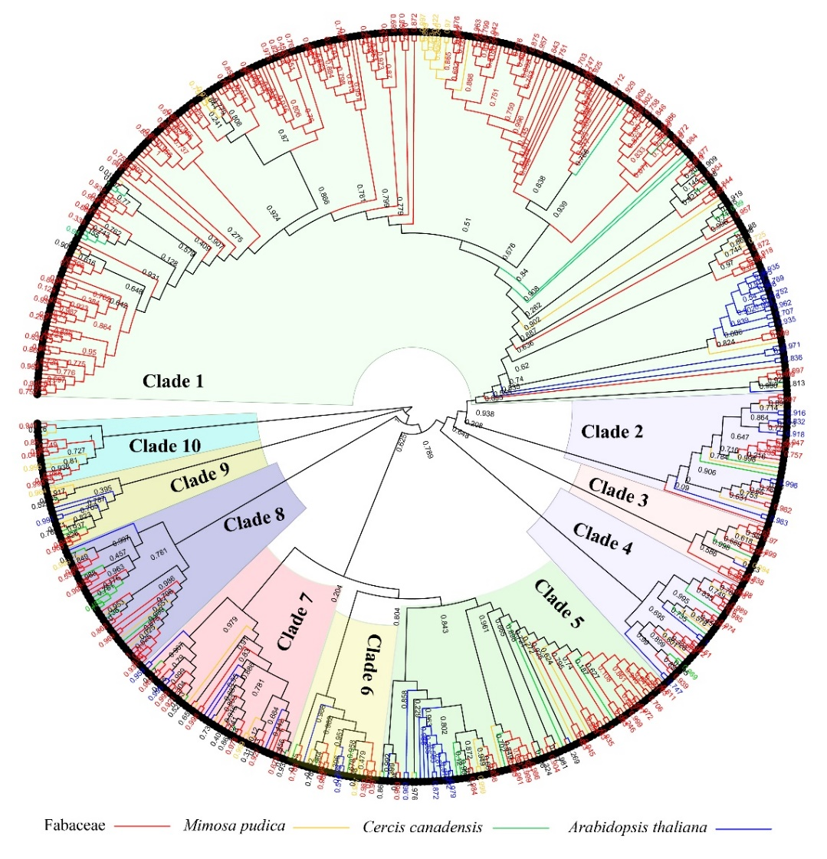
Supplementary Figure 2. Maximum likelihood phylogenetic tree constructed by FastTree of the SAUR gene family in Arabidopsis thaliana, Mimosa pudica, Cercis canadensis, Medicago truncatula and Glycine max.
The ML tree was constructed using FastTree v2.1 with the JTT+CAT model. Then SAUR members were clarified in FigTree v1.4.4. The SAUR family had been divided into 10 clades. Bootstrap support rates were labeled at corresponding branches. Different colorful branches were used to represent SAUR members from different species.

