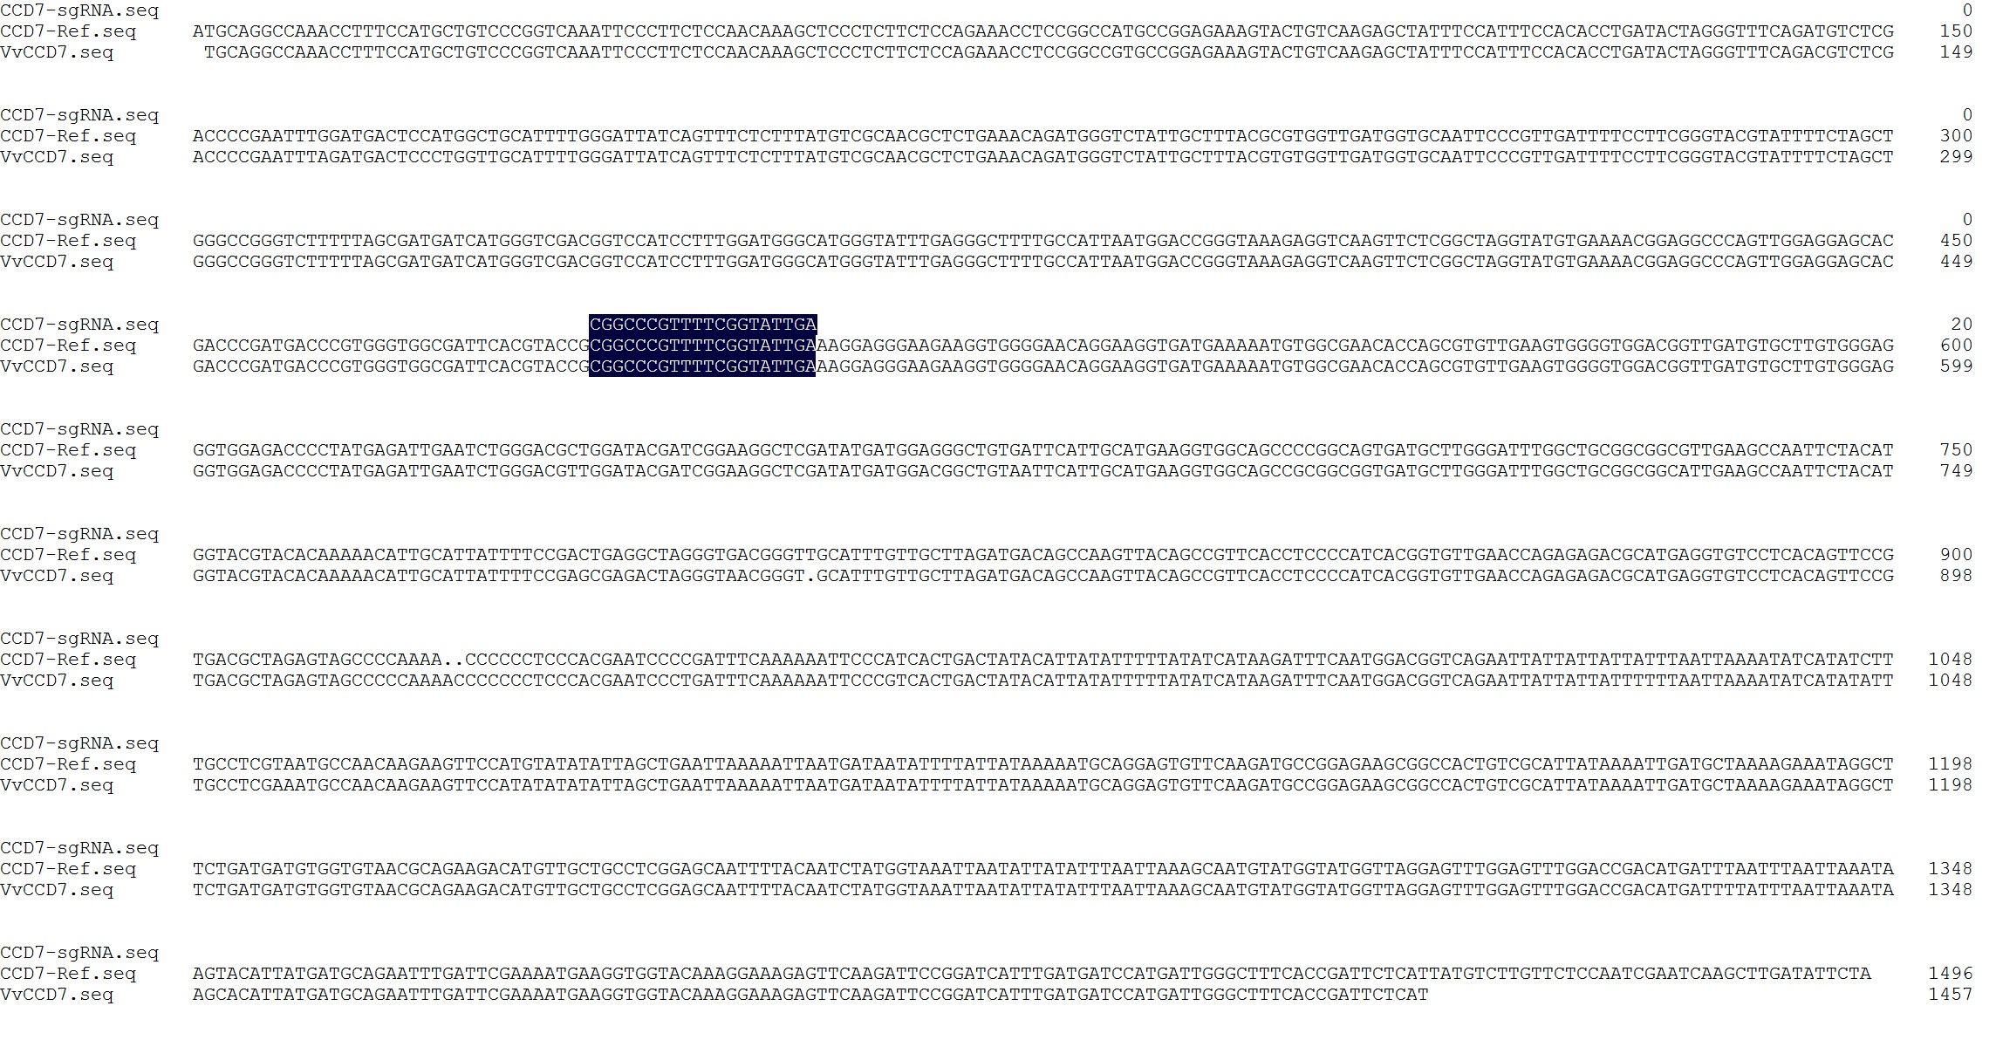
a
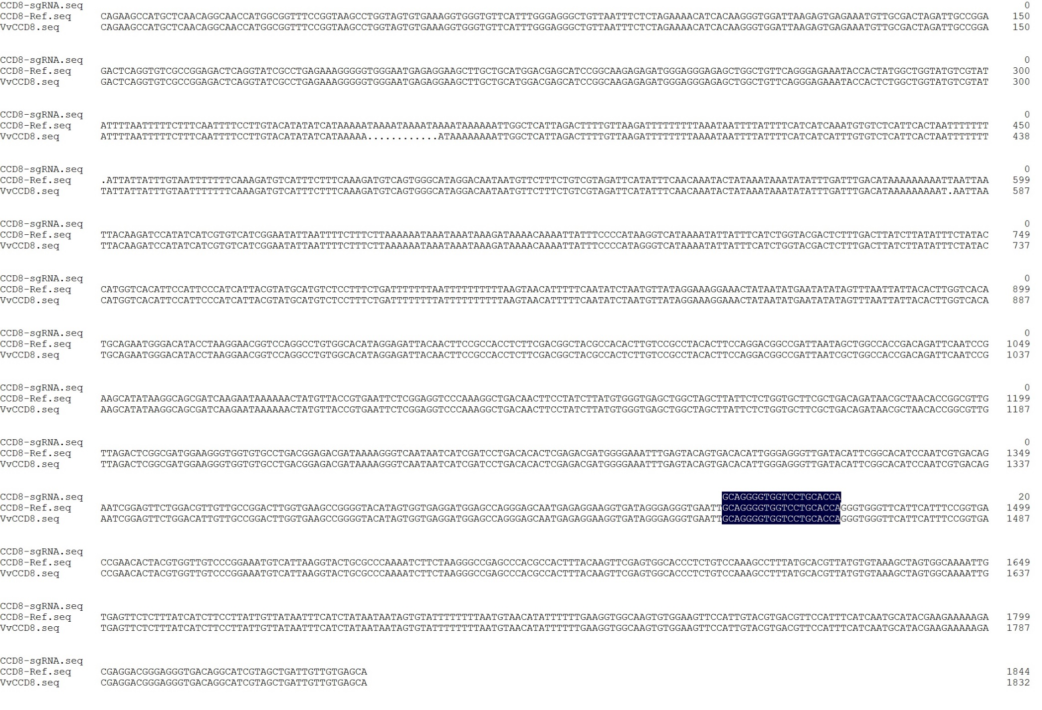
b
Figure S1 Sequencing results of VvCCD7 and VvCCD8 gene fragments amplified from 41B cells. a The target sequence of VvCCD7 gene in 41B. b The target sequence of VvCCD8 gene in 41B. The target sites in VvCCD7 and VvCCD8 genes are highlighted in dark blue

