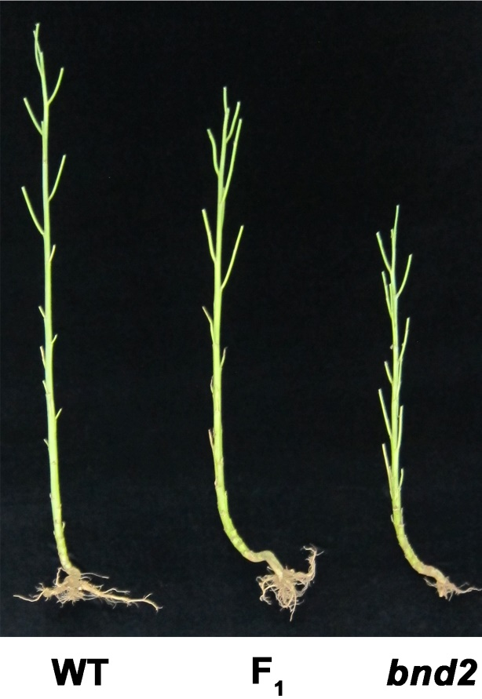
Figure S9. Plant internodes of WT (left), bnd2 (right) and their F₁ hybrid (middle) at maturity.

