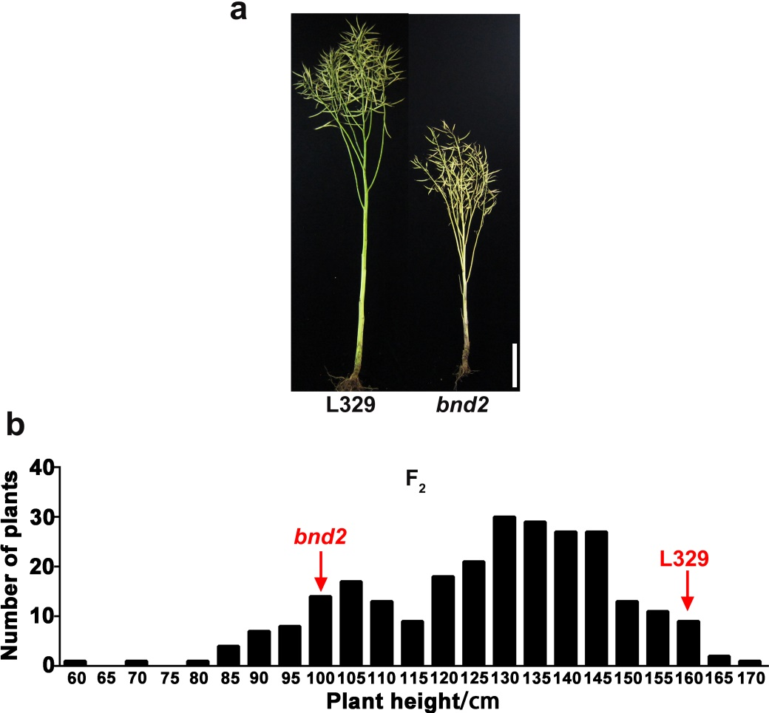
Figure S10. Phenotype and trait inheritance of bnd2 in the cross population. a Phenotype of L329 and bnd2 at maturity. Bar=20 cm. b Plant height frequency distribution of F₂ population of 263 individuals derived from the cross of bnd2 and L329.

