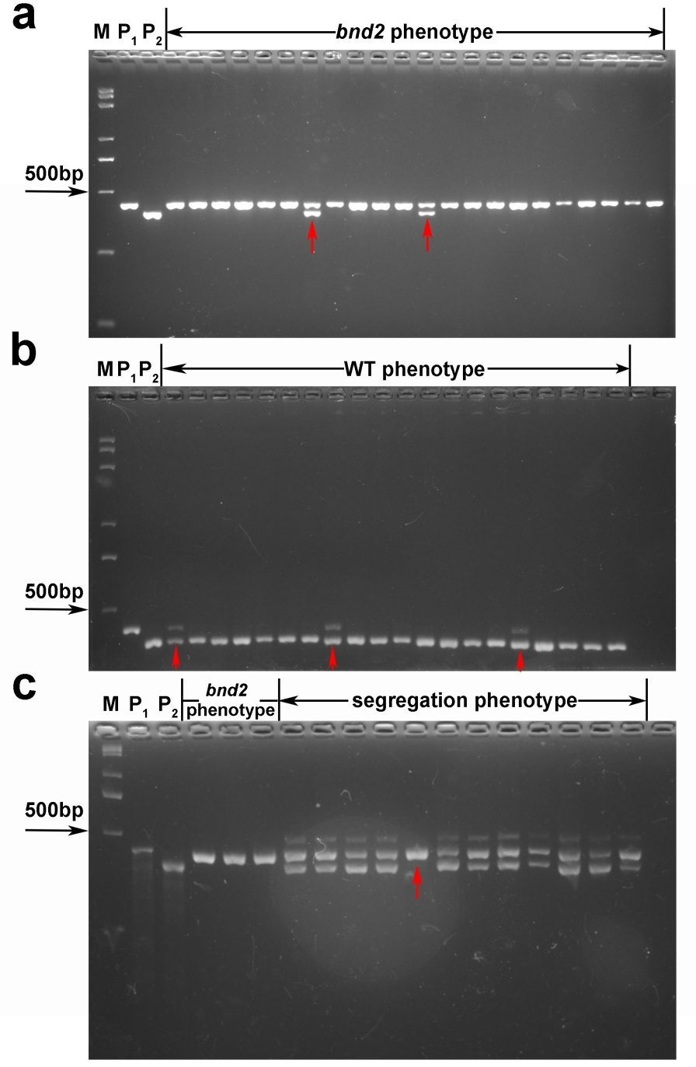
Figure S11. The genotypes of some F_{2:3} lines derived from cross between bnd2 and L329 at the marker ID1656. a The genotypes of the lines with the bnd2 phenotype. b The genotypes of the lines with WT phenotype. c The genotype of the lines with phenotype segregation. M means DNA Marker. P₁ means the mutant parent bnd2. P₂ means the WT parent L329. The red arrow indicates the recombinants between BND2 and the marker ID1656.

