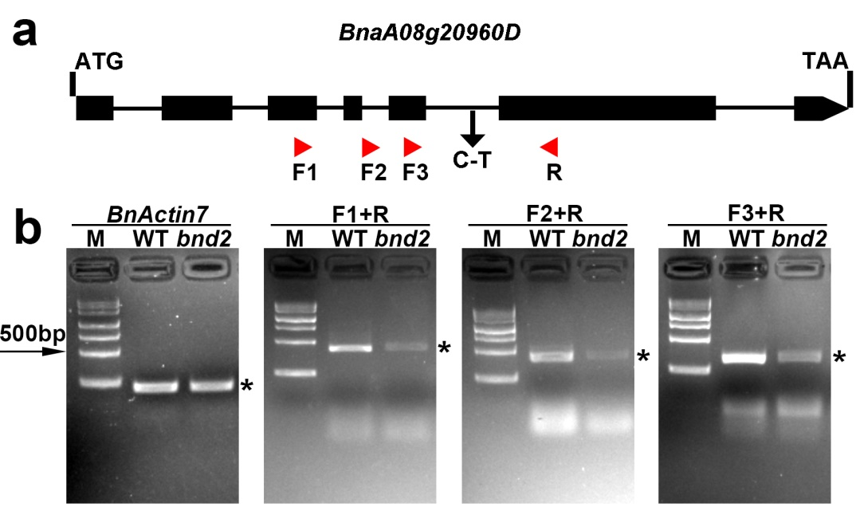

Figure S13. semi-qPCR analysis showing the mRNA expression pattern of BnaA08g20960D in WT and bnd2. a Structure of the BnaA08g20960D gene, a single nucleotide substitution (C-T) between bnd2 and its wild type parent 2B in the fifth intron. Exons and introns were represented as black boxes or black lines, respectively. Red triangles show the position of primers used by semi-qPCR. b semi-qPCR analysis showing the mRNA expression pattern of BnaA08g20960D in WT and bnd2. Seven-day-old WT and bnd2 seedlings grown in soil were sampled for RNA analysis. BnActin7 was used as the internal control. M means DNA Marker. The asterisk represents the PCR product. The experiments were biologically repeated three times with similar results.

