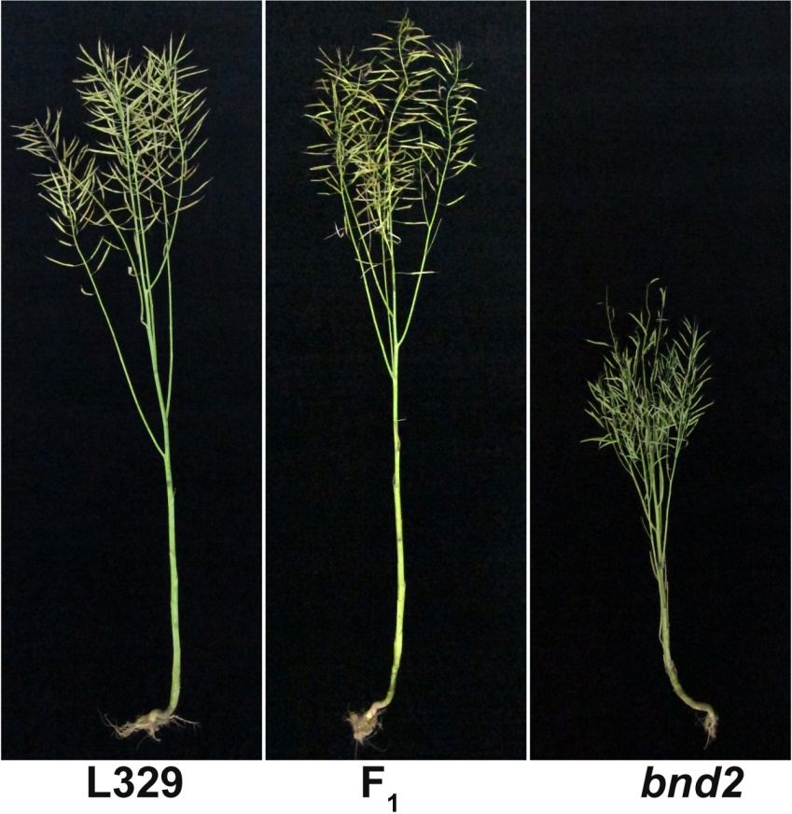

Figure S14. Phenotypes of L329 (left), bnd2 (right) and their hybrid (F_{1,} middle) at the maturation stage.

