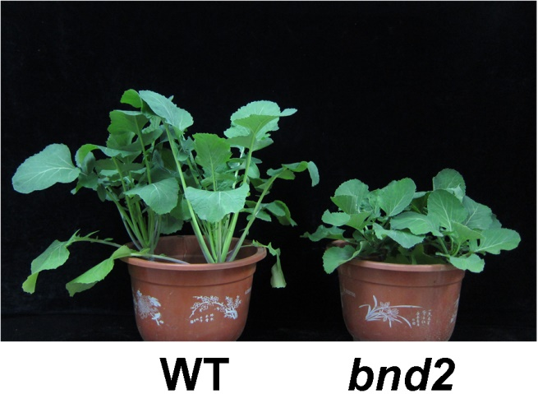

Figure S2. Plants of WT and bnd2 at 5-week-old seedling stage.

