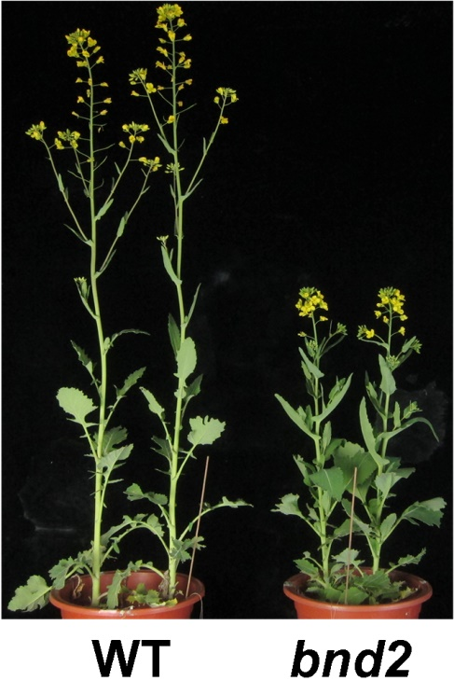

Figure S4. Plants of WT and bnd2 at peak flowering stage.

