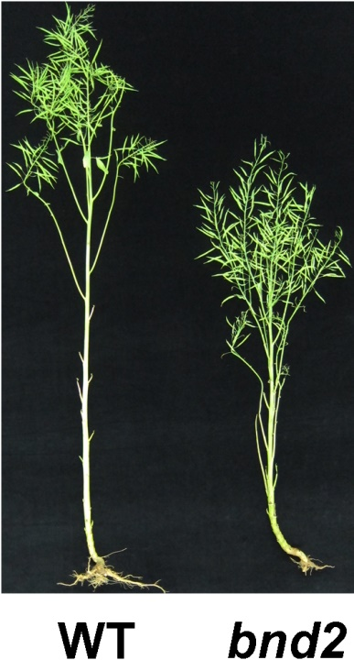

Figure S5. Whole plant phenotype of WT and bnd2.

