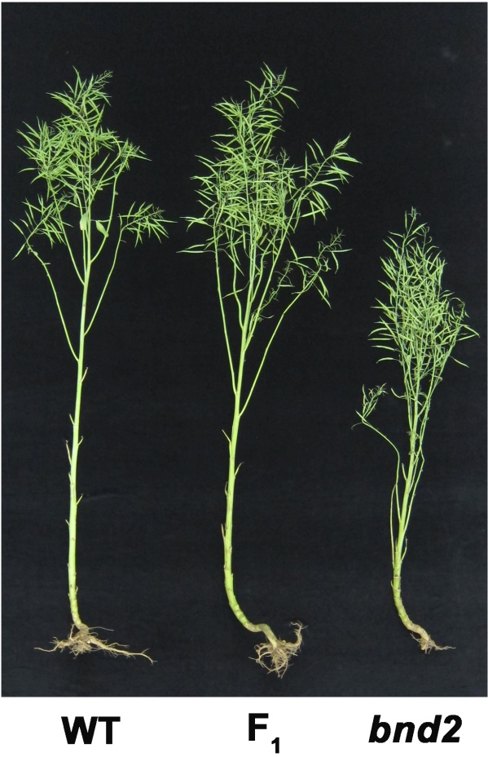

Figure S8. Phenotypes of WT (left), bnd2 (right) and their F₁ hybrid (middle) at maturity.

