Repeatability analysis between samples
Fig. S1 Pearson correlation between samples.

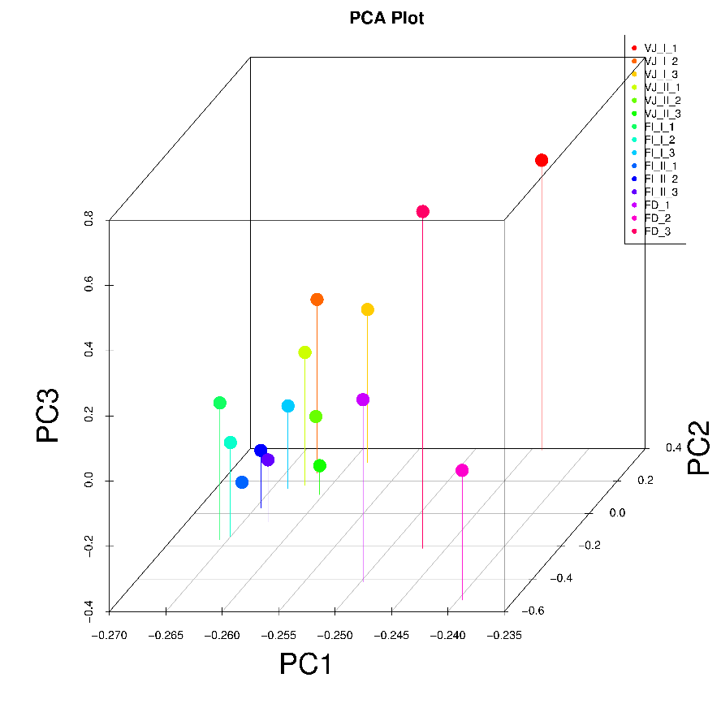
Fig. S2 Principal component analysis based on the expression level in libraries.

