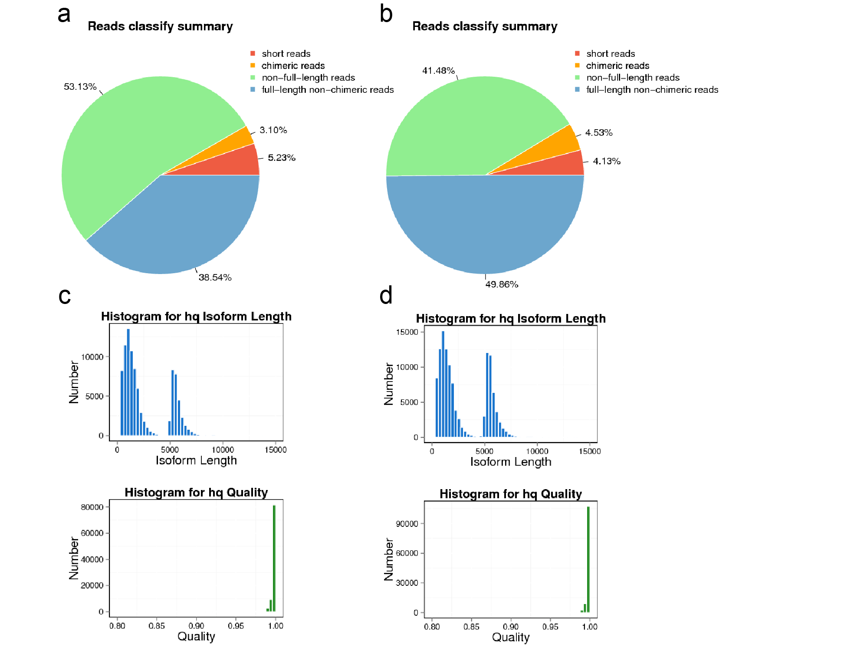

Figure S1 Quality assessment of PacBio Iso-seq data. The pie chart of ROIs showing percentage of the four different categories, full-length non-chimeric reads, non-full-length reads, chimeric reads, and short reads in 0-5 Kb library (a) and 4.5-10 Kb (b) library, respectively. The histogram showing the length (upper panel) and quality score (below panel) distributions of hq isoforms in 0-5 Kb library (c) and 4.5-10 Kb (d) library, respectively.

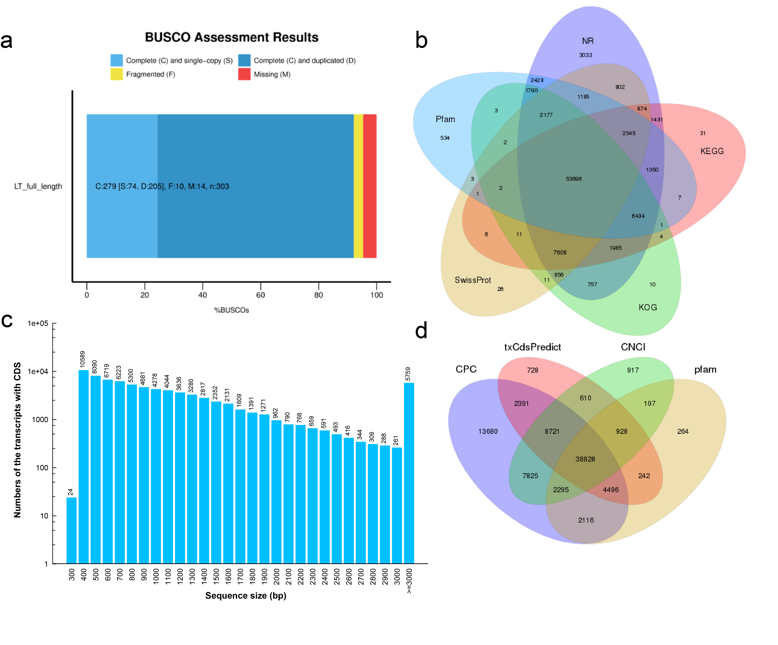
Figure S2 Quality assessment, annotation, CDS, and lncRNA analyses of reference transcriptome. a The completeness of the reference transcriptome generated by PacBio platform was assessed by aligning to BUSCO database. b Venn diagram showing the number of transcripts annotated commonly or uniquely by NR, SwissProt, KEGG, Pfam, and KOG databases. c Length distribution of the predicted CDSs. d Venn diagram showing the number of lncRNAs identified commonly or uniquely by CPC, CNCI, txCdsPredict, and Pfam algorithms.

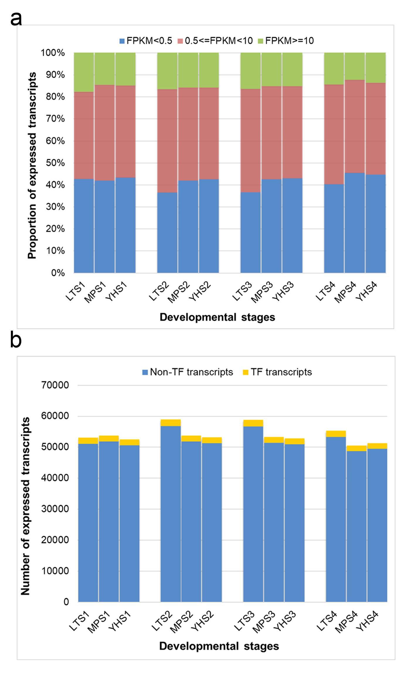

Figure S3 Transcript expression profiling of LT, MP, and YH at four developmental stages. a Proportions of transcripts at different levels (based on FPKM value) in the three genotypes. b Numbers of expressed transcripts (FPKM ≥ 0.5) and TFs in the three genotypes.

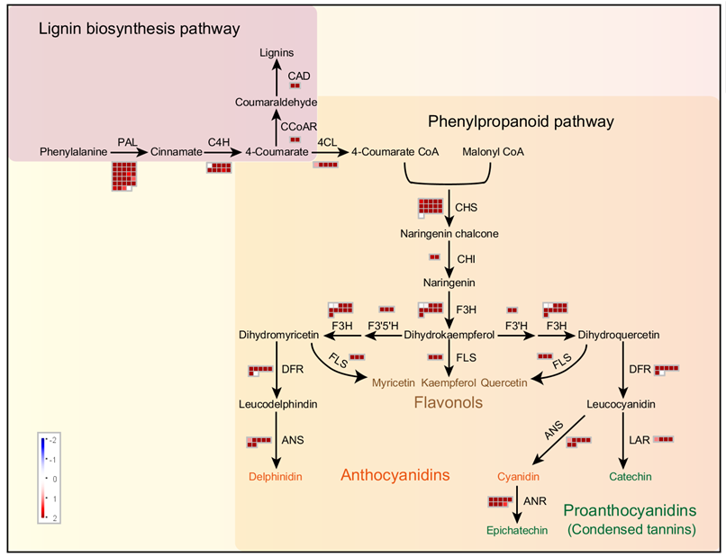

Figure S4 Metabolic pathway analysis of the S1-specific transcripts with corresponding expression values at S1 in LT using MapMan tool. A cell represents a pathway biosynthetic transcript. Dark red and dark blue colours represent higher and lower expression level based on the expression level at S1 in LT genotype.

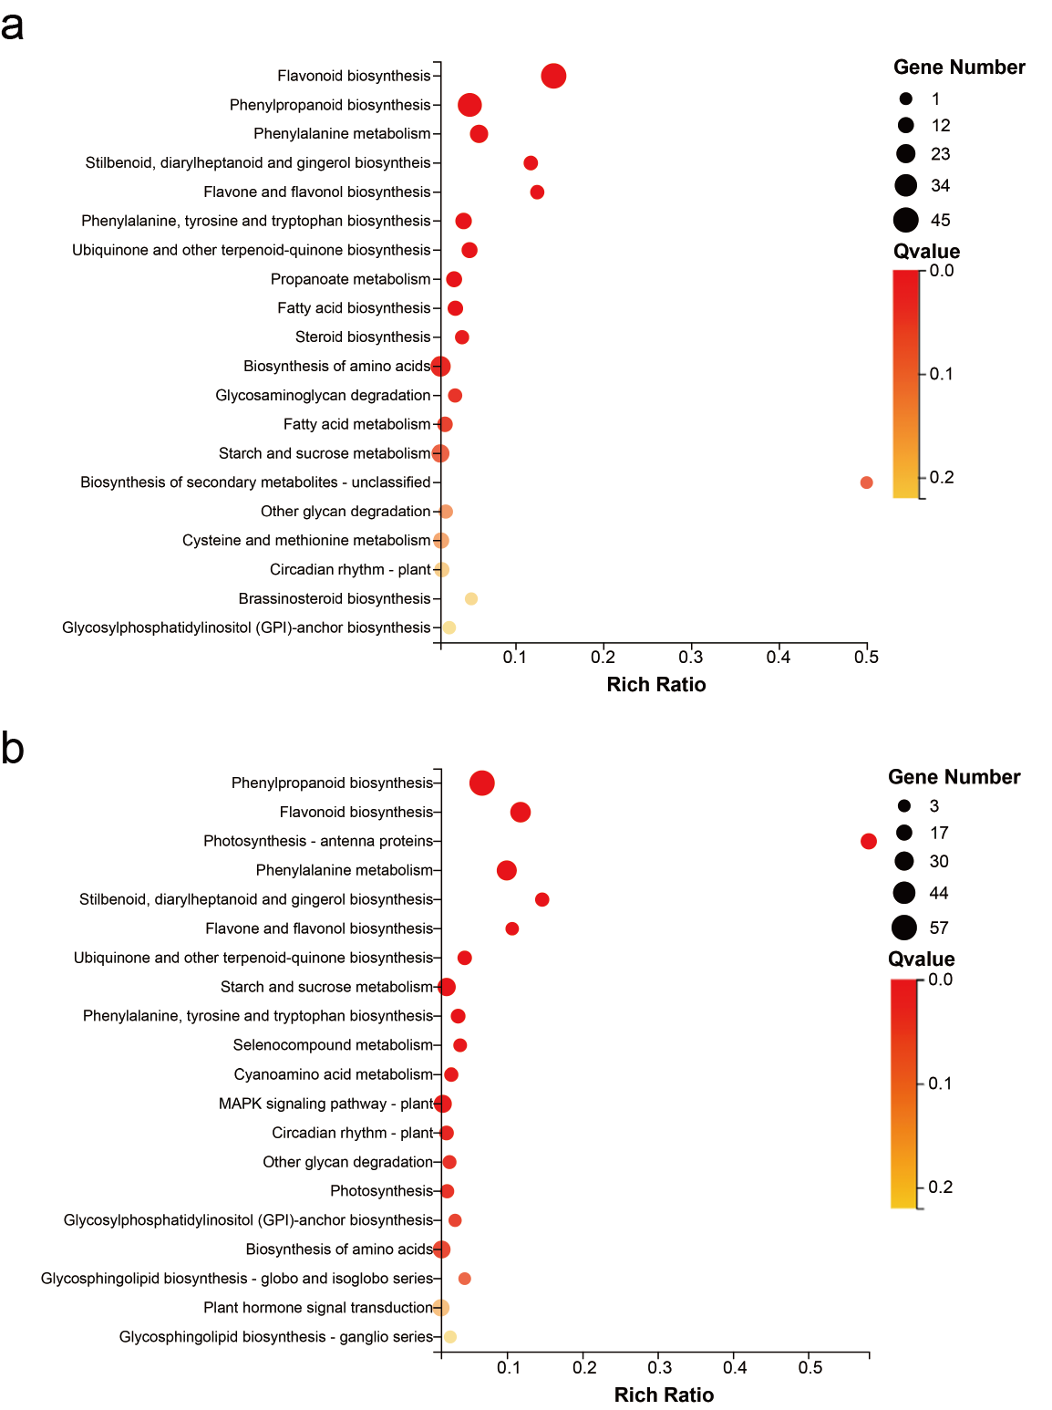

Figure S5 KEGG enrichment analyses of the transcripts within MEbrown module (a) and MEblue module (b). The size of the circle represents the number of enriched transcripts. The colour represents the Qvalue (adjusted p-value).

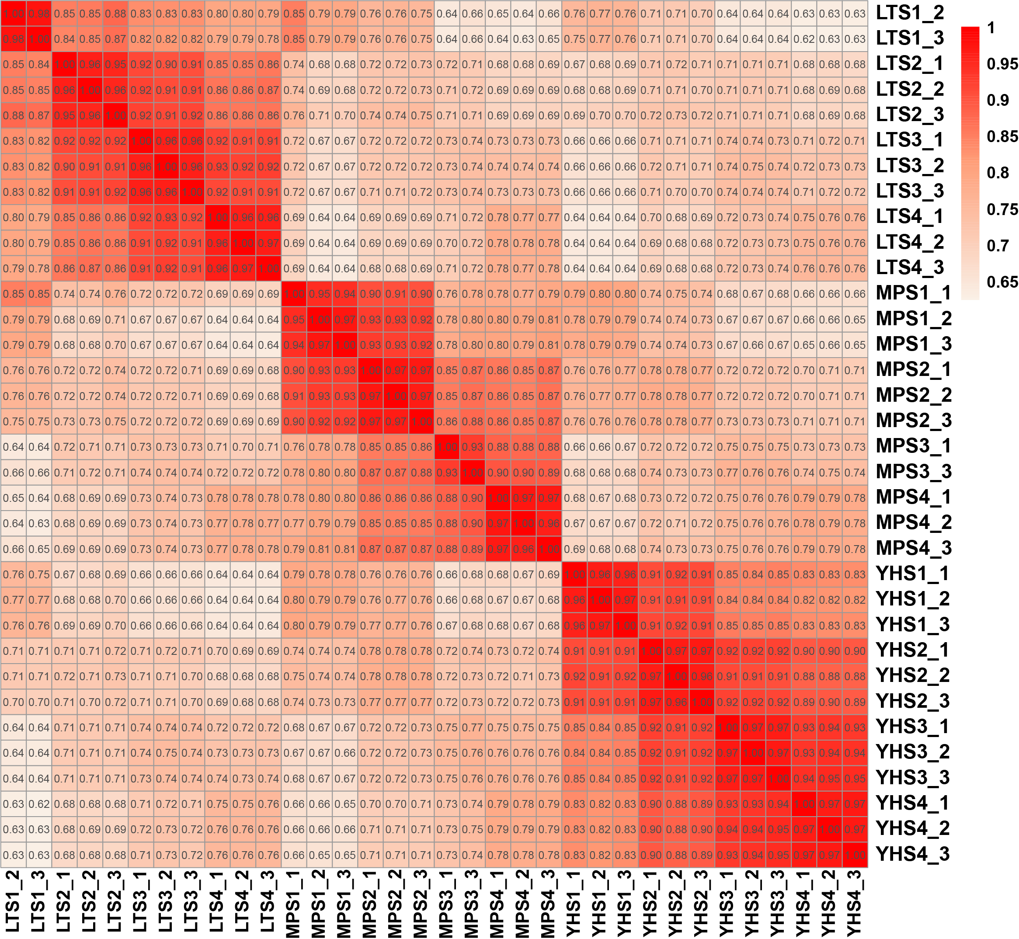

Figure S6 PCC analysis of the biological replicates of LT, MP, and YH genotypes at four stages.
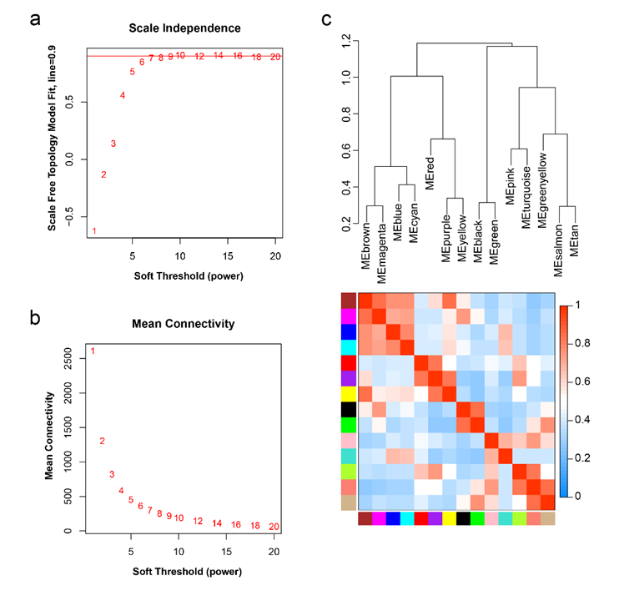

Figure S7 Soft-thresholding powers selection for scale-free topology. a The scale-free fit index under incremental soft-thresholding power. b The mean connectivity under incremental soft-thresholding power. c Hierarchical clustering of 14 WGCNA co-expression modules.

