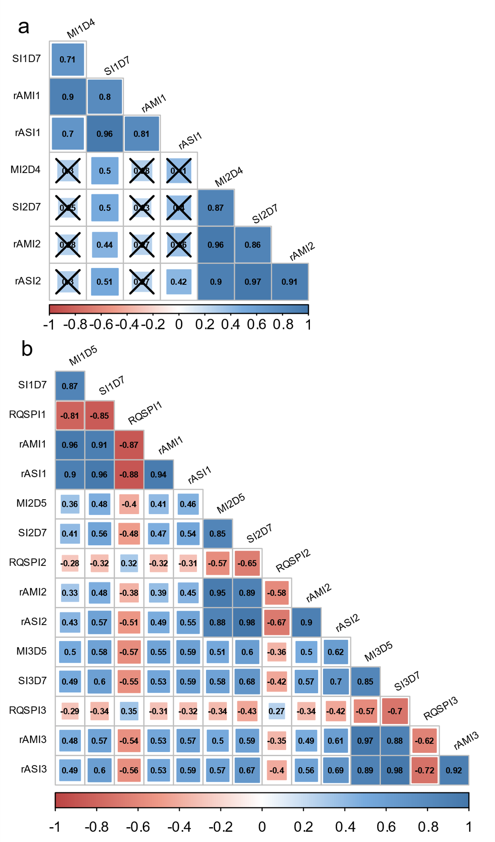
Figure S2. Pairwise correlations (Spearman’s rank correlation) between phenotypic data recorded for the breeding populations 50041-‘Chardonnay’ x ‘Tskhvedianis tetra’ (plot a) and 50042-‘Shavtsitska’ x ‘Glera’ (plot b) during the E. necator infections on leaf discs. The acronyms designate the phenotypic data series: the first letter specifies the infection variable (M→mycelium growth, S→sporulation intensity, RQSP→conidia counts by Malassez counting chamber square-root transformed, rAM→rAUDPC for mycelium growth and rAS→rAUDPC for sporulation intensity), the second letter-number specifies the experiments replicate (I1-I2-I3→inoculation/replicate 1, 2 or 3) and the last letter-number specifies the dpi of observation (D5-D7→dpi 5 or7). Spearman’s rank correlation coefficients crossed represent correlation with p-value > 0.001.

