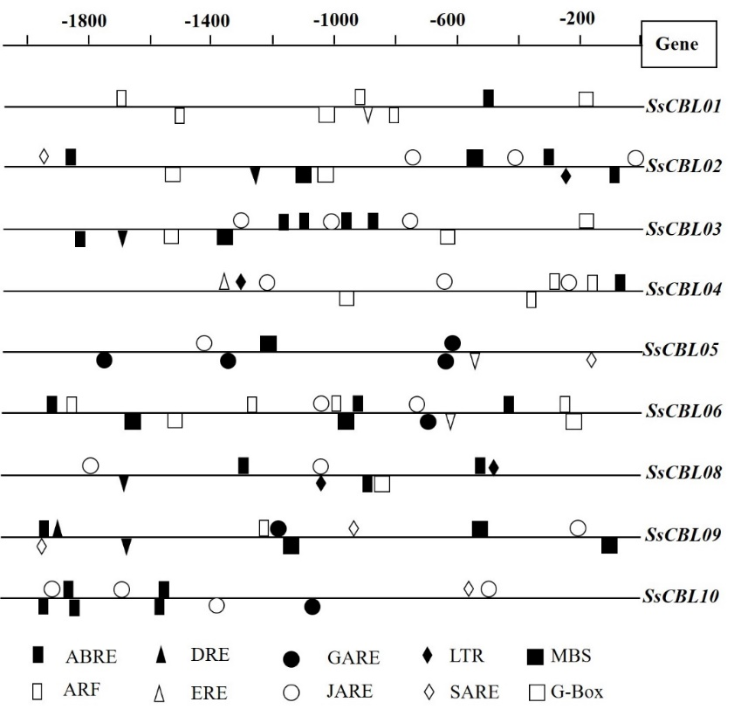
Fig. S1 Phytohormone responsive, putative stress responsive and light responsive cis-elements in the 2 kb 5’-upstream promoter regions of SsCBL genes. The lines represent 5’-upstream regions of SsCBL genes. The cis-elements located in the reverse and forward strand were indicated below and above the lines respectively. Ten figures were used to represent different types of cis-elements.

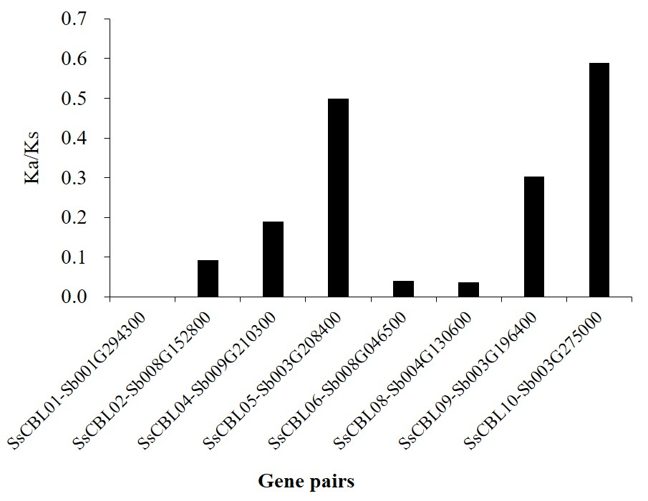
Fig. S2 Nonsynonymous (Ka) and synonymous (Ks) substitution ratios of SsCBLs and orthologous genes in sorghum.

Fig. S3 The proportion of different number of exons in all CBLs from 13 plant species

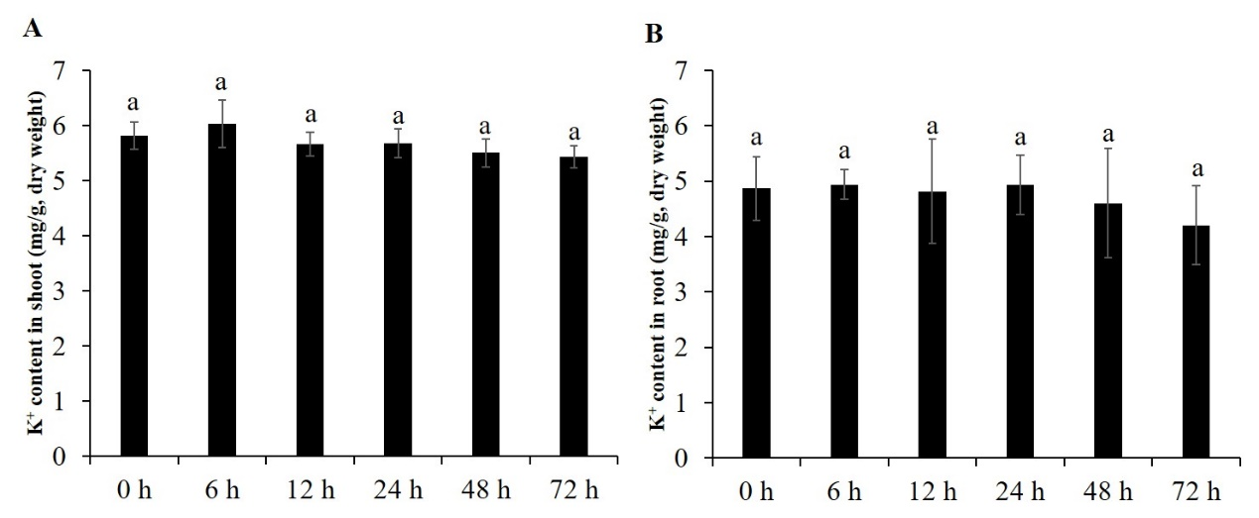
Fig. S4 Potassium content in shoot and root at different time under low K⁺ stress. (A) K⁺ content in shoot; (B) K⁺ content in root, letter “a” on the bar chart indicates no significant difference at p＜0.05.

