Identification of Genetic Loci Associated with Major Agronomic Traits of Wheat (Triticum aestivum L.) Based on Genome-wide Association Analysis
BMC Plant Biology
Woo Joo Jung¹ , Yong Jin Lee², Chon-Sik Kang³, Yong Weon Seo^{1,2*}
¹Department of Plant Biotechnology, Korea University, Seoul 02841, Korea
²Department of Biotechnology, Korea University, Seoul 02841, Korea
³National Institute of Crop Science, Rural Development Administration, Wanju 55365, Republic of Korea
*Corresponding author - Yong Weon Seo
E-mail: seoag@korea.ac.kr

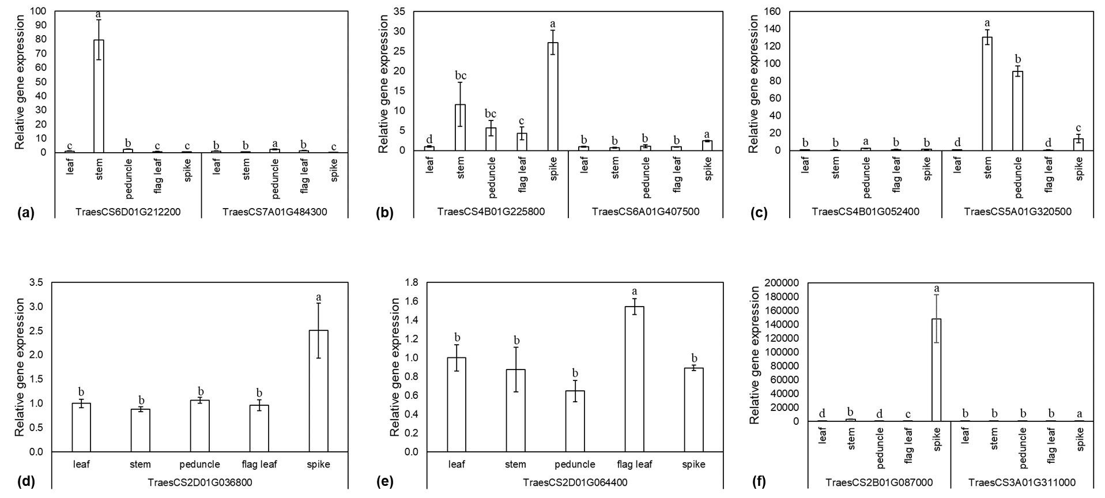
Fig. S6 Relative gene expression of candidate genes associated with (a) days to heading, (b) days to maturity, (c) stem length, (d) spike length, (e) awn length, and (f) number of seeds per spike. Error bars indicate the standard error of the mean (n = 3). Different letters above each bar represent statistically significant differences (P < 0.05) after an analysis of variance (ANOVA) and a Tukey post hoc test.

