Identification of Genetic Loci Associated with Major Agronomic Traits of Wheat (Triticum aestivum L.) Based on Genome-wide Association Analysis
BMC Plant Biology
Woo Joo Jung¹ , Yong Jin Lee², Chon-Sik Kang³, Yong Weon Seo^{1,2*}
¹Department of Plant Biotechnology, Korea University, Seoul 02841, Korea
²Department of Biotechnology, Korea University, Seoul 02841, Korea
³National Institute of Crop Science, Rural Development Administration, Wanju 55365, Republic of Korea
*Corresponding author - Yong Weon Seo
E-mail: seoag@korea.ac.kr

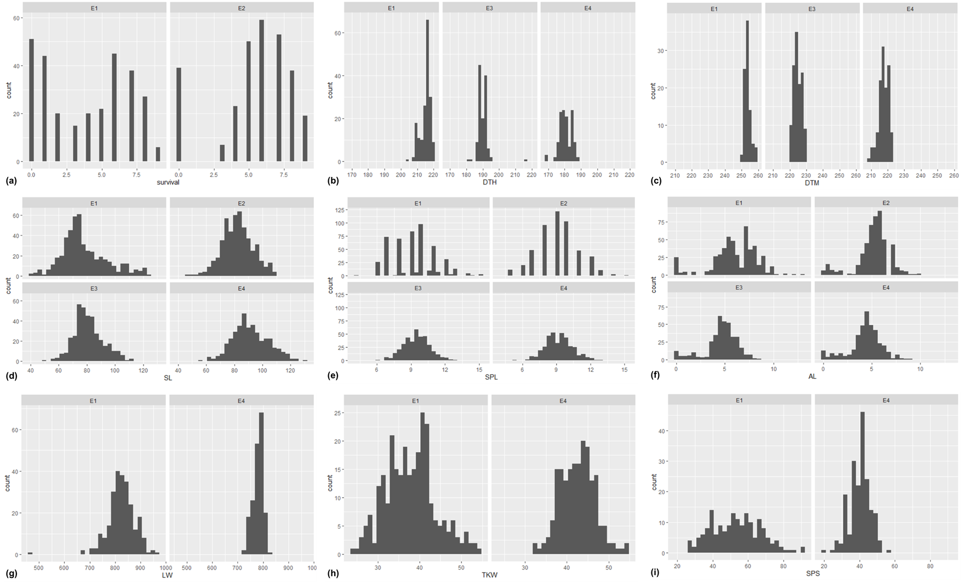
Fig. S1 Frequency distribution of the observed phenotypic data in 287 wheat genotypes. (a) survival; winter survival rate (0: 0-10% to 9: 90-100%), (b) DTH; days to heading, (c) DTM; days to maturity, (d) SL; spike length (cm), (e) SPL; spike length (cm), (f) AL; awn length (cm), (g) LW: liter weight (g), (h) TKW; thousand-kernel weight (g), (i) SPS: Number of seeds per spike. E1: Deokso in 2018-2019 season, E2: Deokso in 2019-2020 season, E3: Jeonju in 2018-2019 season, E4: Jinju in 2018-2019 season

