Identification of Genetic Loci Associated with Major Agronomic Traits of Wheat (Triticum aestivum L.) Based on Genome-wide Association Analysis
BMC Plant Biology
Woo Joo Jung¹ , Yong Jin Lee², Chon-Sik Kang³, Yong Weon Seo^{1,2*}
¹Department of Plant Biotechnology, Korea University, Seoul 02841, Korea
²Department of Biotechnology, Korea University, Seoul 02841, Korea
³National Institute of Crop Science, Rural Development Administration, Wanju 55365, Republic of Korea
*Corresponding author - Yong Weon Seo
E-mail: seoag@korea.ac.kr

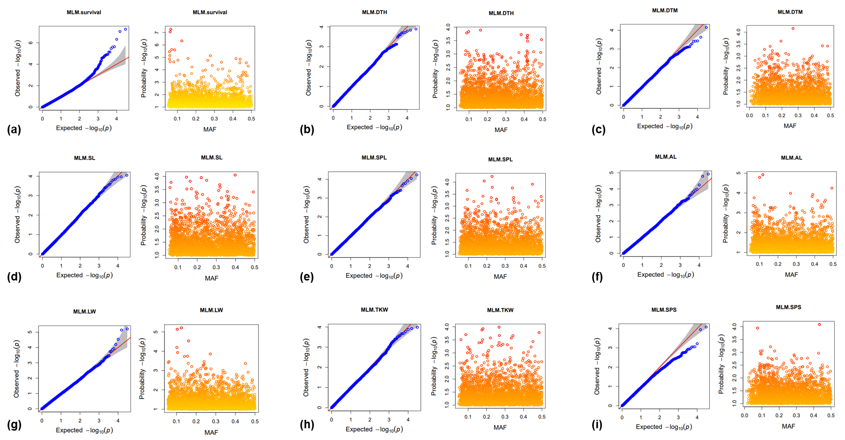
Fig. S2 Q-Q plot and minor allele frequency (MAF) plot of SNPs associated with nine agronomic traits. In the Q-Q plot, X-axis and Y-axis represent cumulative P-values and observed P-values on a -log10 scale, respectively. In the MAF plot, each SNP is shown as circles and X-axis and Y-axis represent the MAF and the significance of marker-trait association, respectively. (a) winter survival rate, (b) days to heading, (c) days to maturity, (d) stem length, (e) spike length, (f) awn length, (g) liter weight, (h) thousand-kernel weight, (I) the number of seeds per spike

