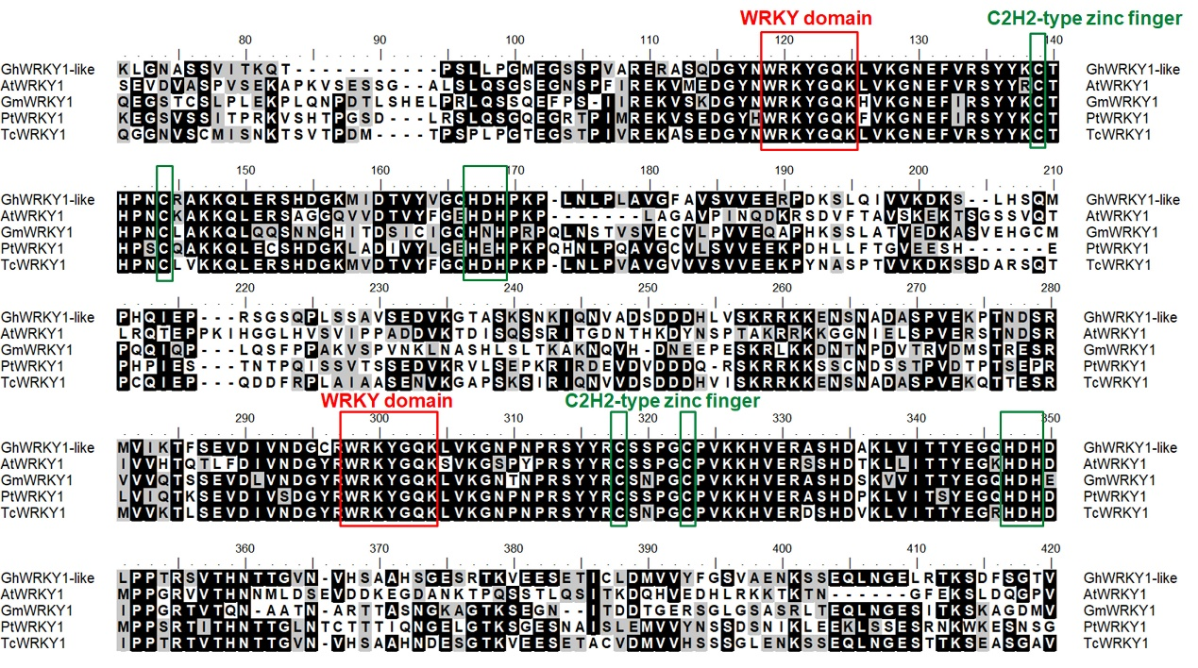
Additional file 1: Figure S1. Sequence and phylogenetic analysis of GhWRKY1-like. Sequence alignment of the amino acid sequence of GhWRKY1-like (XP_016696352) with AtWRKY1 (AEC05881), GmWRKY1 (XP_003518571), PtWRKY1 (XP_006375555), and TcWRKY1 (XP_007049283). Conserved WRKY domain and zinc finger motif are shown in red box and green box, respectively.

