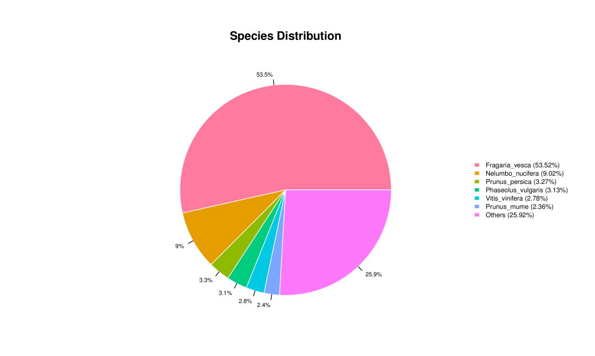
Fig. S1 Species distribution of the BLAST hits for each unigenes based on Nr database.

