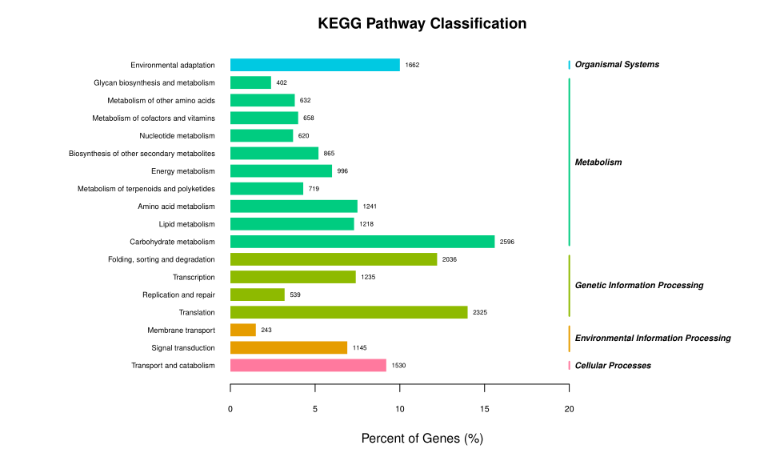
Fig. S3 KEGG pathway functional category of the assembled unigenes.

