Full-length transcriptomic identification of R2R3-MYB family genes related to secondary cell wall development in Cunninghamia lanceolata (Chinese fir)
Hebi Zhuang^{1§}, Sun-Li Chong^{1§}, Borah Priyanka¹, Xiao Han¹, Erpei Lin¹, Zaikang Tong¹, Huahong Huang^{1*}

¹State Key Laboratory of Subtropical Silviculture, Zhejiang A&F University, Lin'an, Hangzhou 311300, China
§These authors contributed equally to this work.

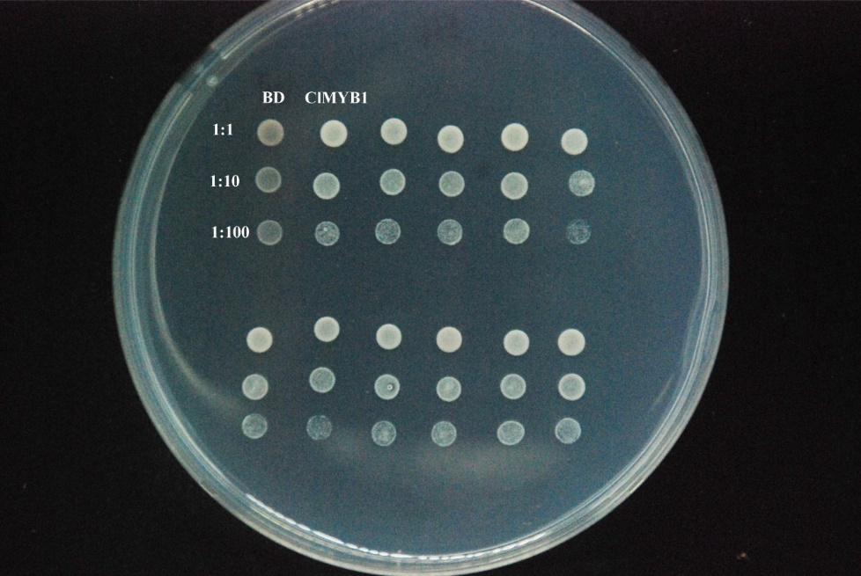
SD/-Trp

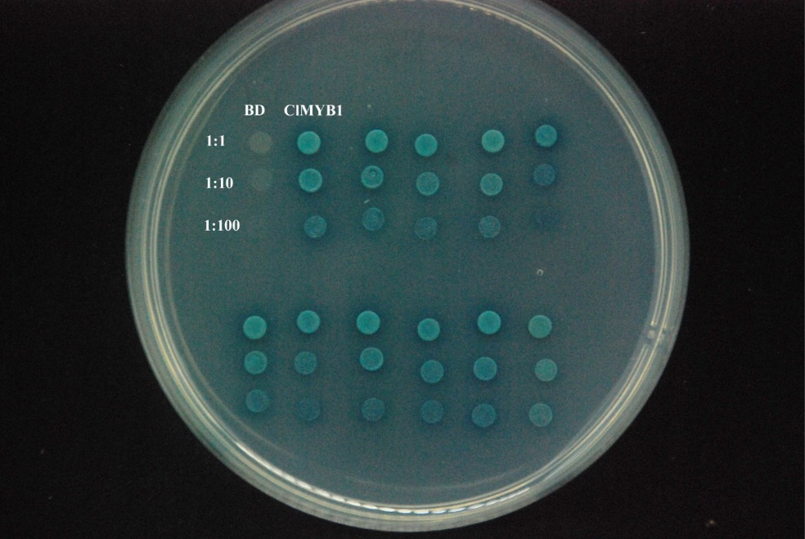
SD/-3

Image 1. The original gel plate photo of Figure 7c in the manuscript
The gel plate photo illustrated transcriptional activation assay of ClMYB1. The yeast strain harboring empty vector (BD) and ClMYB1 were grown in SD medium lacking tryptophan (SD/-Trp) and three amino acid elements: tryptophan, histidine, and Adenine (SD/-3); to test the ability of ClMYB1 on self-activation. Those spots diluted in 1:1 was cropped and used in Figure 7c in the manuscript (red rectangle box).

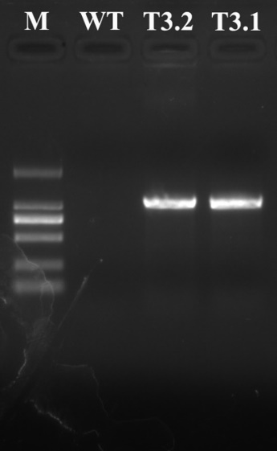

Image 2. The original gel photo of Figure 8B(a) in the manuscript.
The gel photo contained PCR band of ClMYB1 amplified from the genomic DNA in transgenic N. benthamiana and wild type plant. M: DNA marker (DL2000, TaKARa), WT: wide-type, T3.1 and T3.2: two independent T3 generation lines.

ClUBC
ClActin

ClMYB1
ClGAPDH

Image 3. The original gel photo of Figure 8B(b) in the manuscript.
The gel photo contained ClMYB1 (lane 8-13) transcripts detection by semi-quantitative RT-PCR in transgenic N. benthamiana and wild type plant with ClActin (lane 2-7) was used as reference gene. The portion showing amplified bands of ClMYB1 and ClActin in WT, T3.1 and T.32 (red rectangle box) were cropped and used in Figure 8B(b). M: DNA marker (DL2000, TaKaRa), WT: wide-type, T3.1 and T3.2: two independent T3 generation lines. T2.1, T2.2 and T2.3: three independent T2 generation lines.

