Additional file 1:
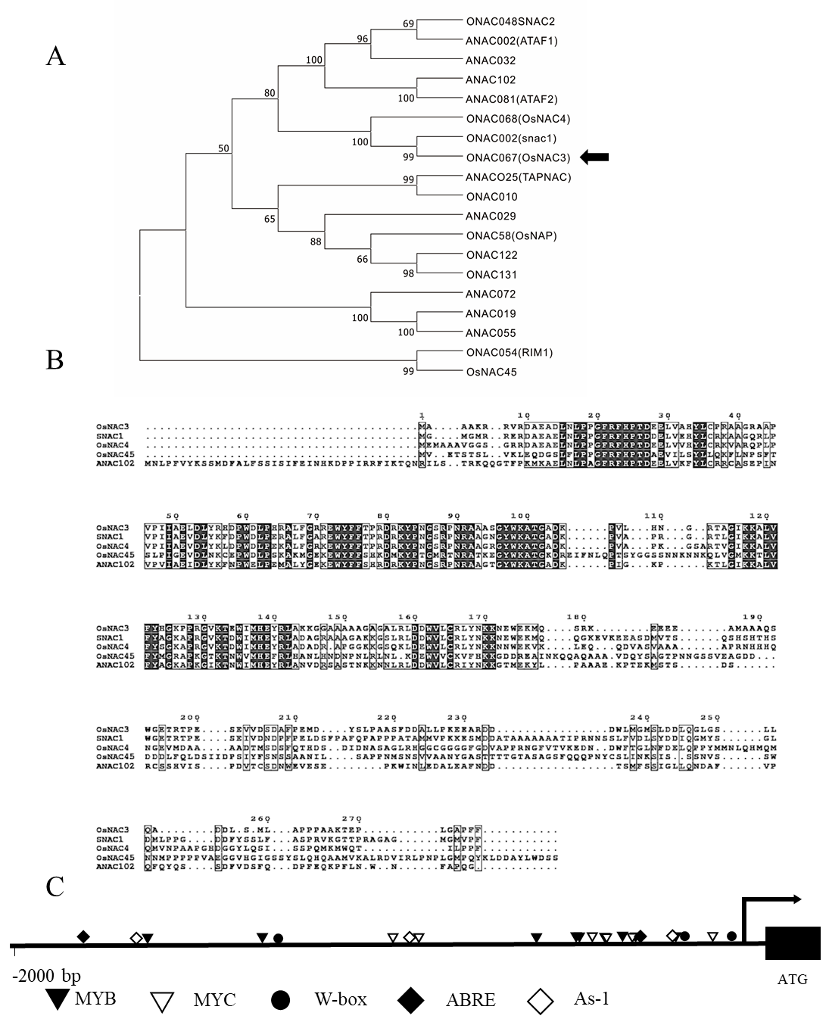
Fig. S1 Bioinformatics analysis of OsNAC3. (A) Phylogenetic tree of OsNAC3. 17 homologs sharing with more than 75% identity to OsNAC3, together with OsNAC3 and OsNAC45, were used to construct the phylogenetic tree. Multiple sequence alignment was performed using the Clustal Omega program and the phylogenic tree was created and visualized using Espript3.0. (B) Multiple sequence alignment of NAC proteins from rice and Arabidopsis. (C) Distribution of cis-acting elements in the promoter region of OsNAC3.

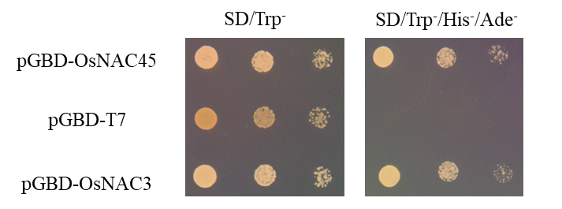
Fig. S2 Self-activation analysis of OsNAC3. Yeast carrying pGBD-OsNAC45 (positive control), pGBD-T7 (negative control) or pGBD-OsNAC3 were spotted on the SD/Trp- (left) or SD/Trp-/His-/Ade- plates (right) for 3 days at 28 ℃.

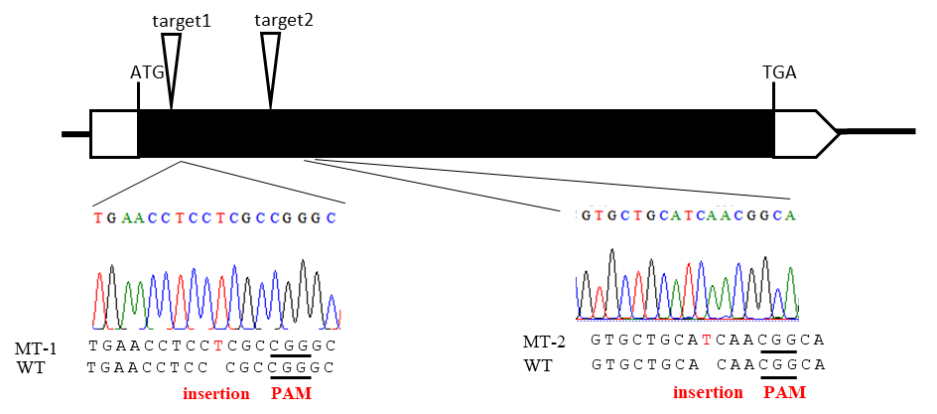
Fig. S3 OsNAC3 sequence of two independent mutants generated by CRISPR/Cas9 mutagenesis. The black box indicates the exon.

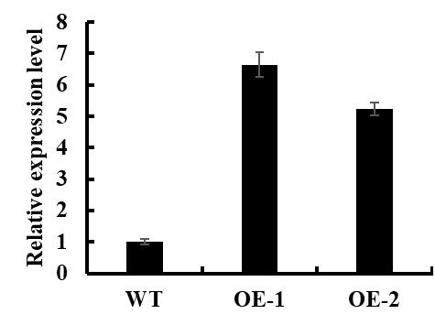
Fig. S4 Relative expression levels of OsNAC3 in the OsNAC3-overexpression lines (OE-1, OE-2); OE-1 and OE-2 were chosen for further experiments. Data are means ± SD of three biological replicates.

Table S1. Primers used in this study

225300gRTF | GGCGGACCTGAACCTCCCGCGTTTTAGAGCTAGAAAT
t225300OsU3T | GCGGGAGGTTCAGGTCCGCCTGCCACGGATCATCTGC
OsNAC3-g RT | GACAAGCCCGTGCTGCACAA
OsNAC3-u6a | TTGTGCAGCACGGGCTTGTC
OsNAC3-1-y-F | CCAACAACCCACCACCCTCA
OsNAC3-1-y-R | CGCGTCTCCCCCCACGACTG
OsNAC3-2-y-F | GTTTTAGAGCTAGAAAT
OsNAC3-2-y-R | CGGCAGCCAAGCCAGCA
OsNAC3-pox-F | CCCAAGCTTCATGGCGGCGGCGAAGCGGCGAGT
OsNAC3-pox-R | CGCGGATCCTCAGAAGAATGGCGCGCCGA
OsNAC3-GFP-F | CCCAAGCTTCATGTTTGACCGTTCGTCTTATTCAAAAG
OsNAC3-GFP-R | CGCGGATCCGAAGAATGGCGCGCCGAGCGGC
OsNAC3-RT-F | ATCAAGAAGGCGCTCGTGT
OsNAC3-RT-R | CGTGCATGATCCACTCCGTC
OsRAB21-RT-F | CACACCACAGCAAGAGCTAAGTG
OsRAB21-RT-R | TGGTGCTCCATCCTGCTTAAG
OsERF3-RT-F | CAGCAATAGCACGGTAGACA
OsERF3-RT-R | AGGAGTCGGAGTCACTTTGT
OsPP2C68-RT-F | CGCAGCTCCGACAACATCT
OsPP2C68-RT-R | GCTGGGTGACACTCTCTCTACAAG
OsLEA3-1-RT-F | AATGATTTCCCTTTGGGTC
OsLEA3-1-RT-R | CATCAGTACACATCACCCA
OsPM1-RT-F | ACACACCGGCCAATCGAT
OsPM1-RT-R | AGCGGGAAACACAAAGTGAAG

