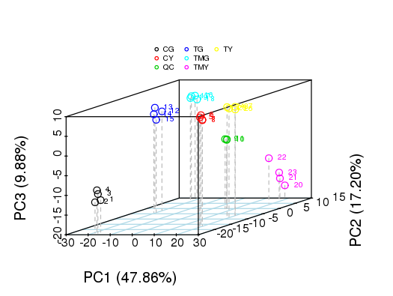
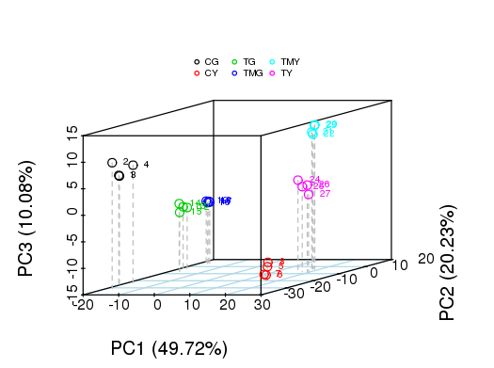
B
A

Supplementary Figure 4 Principal component analysis (PCA) score diagram in (A) negative, (B) positive ion mode of metabolic profiles in the wheat roots and leaves
Note: CG: the control wheat roots, TG: 150 mM NaCl treated wheat roots, TMG: 5 mM 3-MA + 150 mM NaCl treated wheat roots, CY: the control wheat leaves, TY: 150 mM NaCl treated wheat leaves, TMY: 5 mM 3-MA + 150 mM NaCl treated wheat leaves. PC1, the first principal component, PC2, the second principal component. The scatter points of different colors represent the samples of different experimental groups, and the ellipse is the 95% confidence interval.

