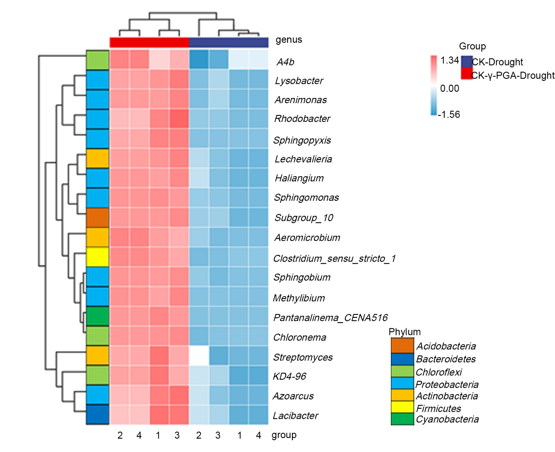
Fig. S10 The relative abundance heatmap of the genus in rhizosphere soil of maize added γ-PGA identified by LEfSe analysis.

