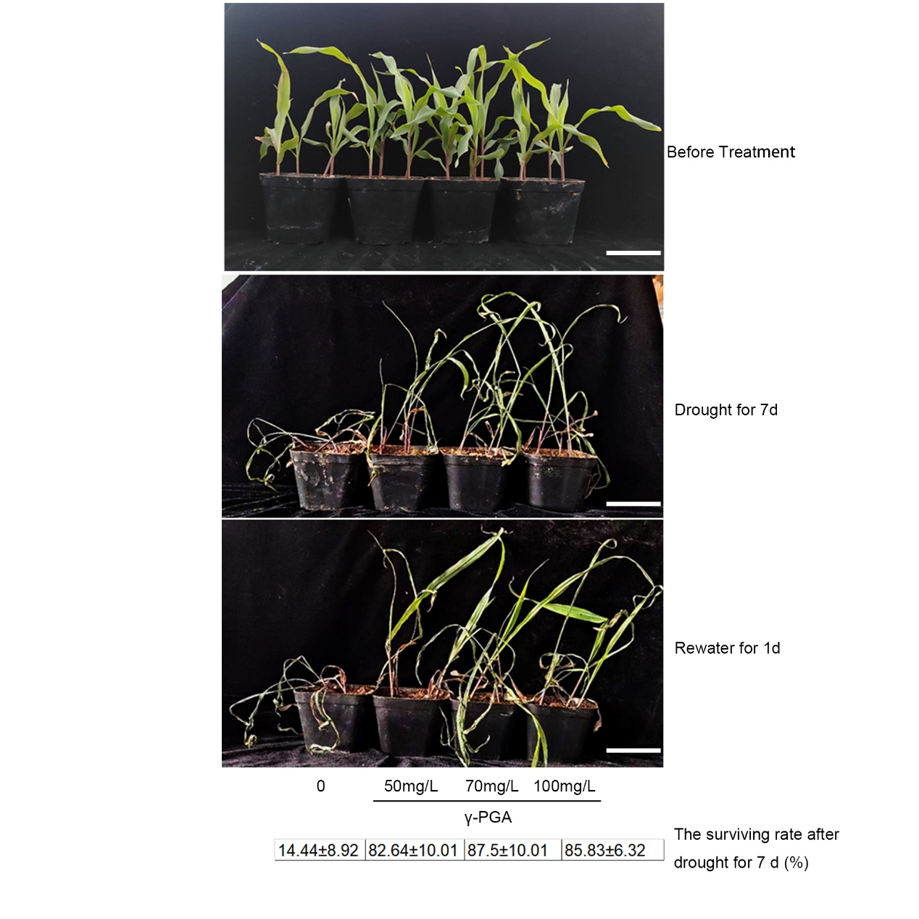
Fig. S1 Phenotypes of maize with added γ-PGA under drought stress. Phenotypes of maize with added different concentrations (0, 50 mg/L, 70 mg/L, 100 mg/L) of γ-PGA under the 7 d drought stress treatment and after re-watering for 1 d. Bars=10 cm.

