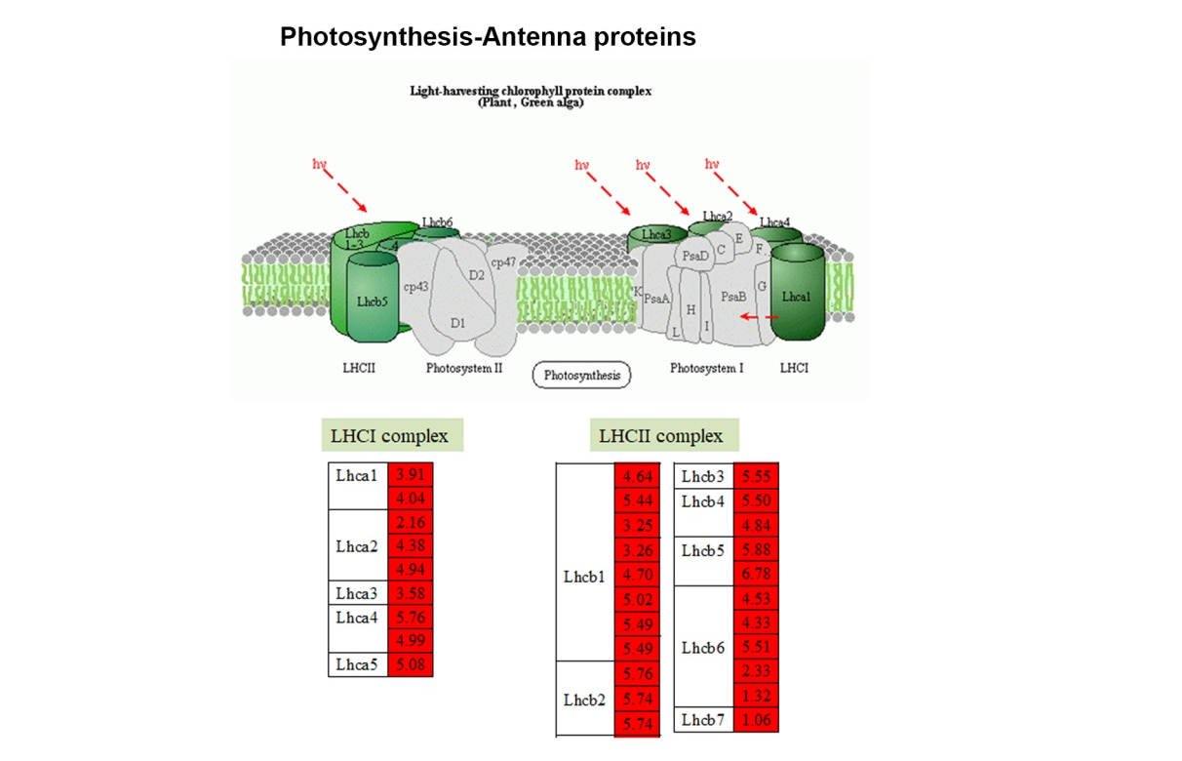

Fig. S4 The DEGs involved in photosynthesis-antenna proteins. The DEGs involved in photosynthesis. The leaf from the maize with added γ-PGA under drought stress was collected for RNA sequencing. The absolute values of log2 (CK+γ-PGA/CK) ≥1 and FDR < 0.001 were used as the criteria for DEGs. The color of the box represents up (red) and down (green)-regulated (CK+ γ-PGA/CK) genes, and the value in the box is the log2 (CK+ γ-PGA/CK) of the genes in the leaf (CK+ γ-PGA/CK) under drought stress. The pattern of photosynthesis-antenna proteins comes from KEGG (http://www.genome.jp/kegg/).

