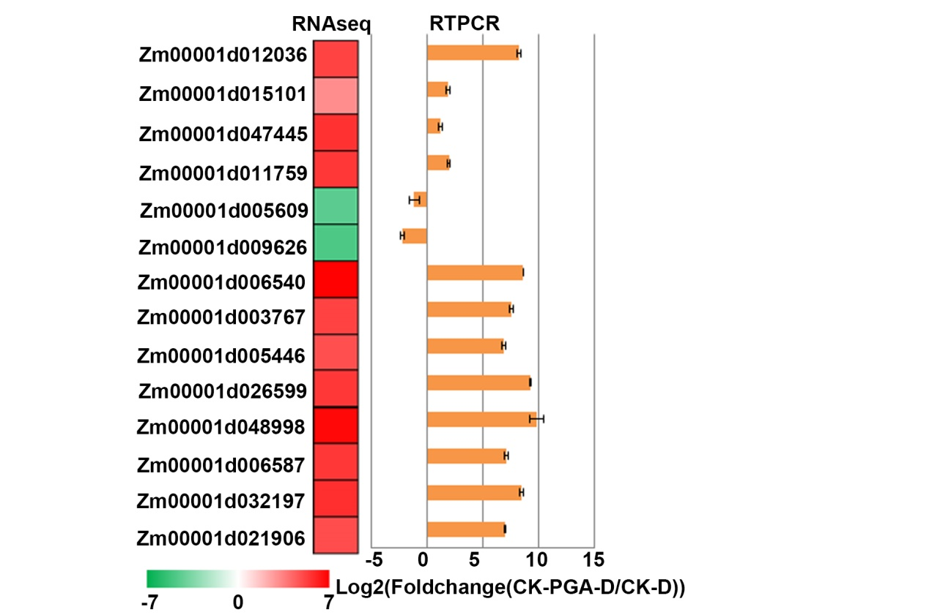

Fig. S5 Validation of DEG identified in RNAseq by real-time RT-PCR. The left heatmap showed the log2 fold changes of the DEGs identified in RNAseq. The right bar graph was the results by real-time RT-PCR. Log2 values (CK-PGA-D/CK-D) were used to generate the plot. Expression levels of genes were analyzed by real-time RT-PCR, fold changes in transcripts were calculated by 2^{-ΔΔCt} method with ZmTub as an internal control.

