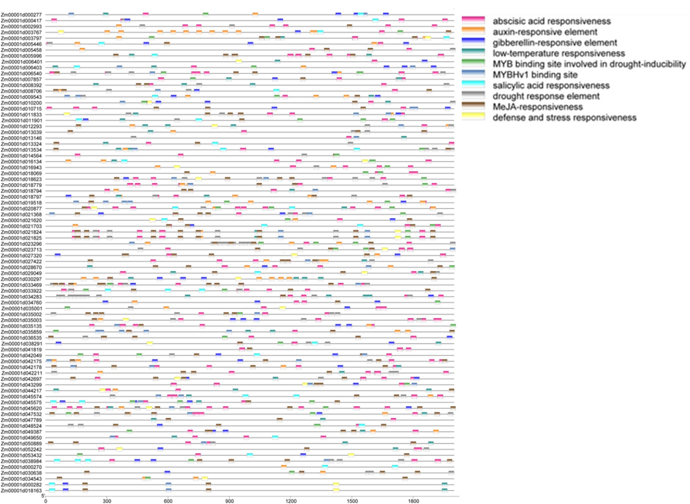
Fig. S6 The promoter elements analysis of the DEGs involved in photosynthesis. Different color squares represent different elements, and red squares represent ABA responsive elements.

