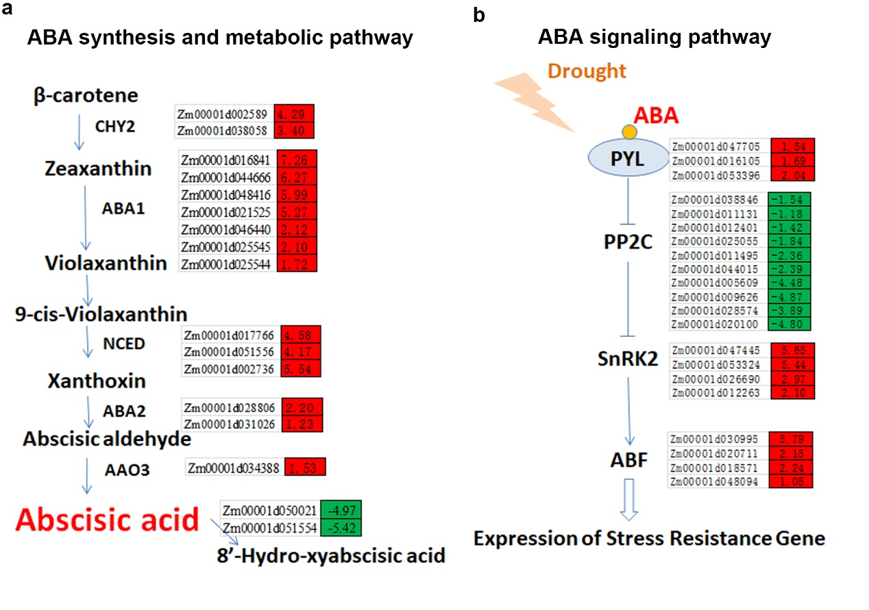

Fig. S8 DEGs involved in ABA biosynthesis and ABA signaling pathway. Leaves from maize with added γ-PGA under drought stress was collected for RNA sequencing. The absolute values of log2 (CK+ γ-PGA/CK) ≥1 and FDR < 0.001 were used as the criteria for DEGs. The color of the box represents up (red) and down (green)-regulated (CK+ γ-PGA/CK) genes, and the value in the box is the log2 (CK+ γ-PGA/CK) of the genes in the leaf (CK+ γ-PGA/CK) under drought stress.

