Figure S1 Geographical distribution of all teosinte accessions. Nic, nicaraguensis; Lux, luxurians; Dip, diploperennis; Per, perennis; Hue, huehuetenangsis; Mex, mexicana; Par, parviglumis. The parviglumis and mexicana races are defined in the key: Par_S, Southern Guerrero; Par_E, Eastern Balsas; Par_O, Oaxaca; Par_B, Central Balsas; Par_J, Jalisco; Mex_P, Puebla; Mex_C, Central Plateau; Mex_D, Durango; Mex_H, Chalco; Mex_N, Nobogame. The detailed georgraphical information for teosinte is listed in Data S4.

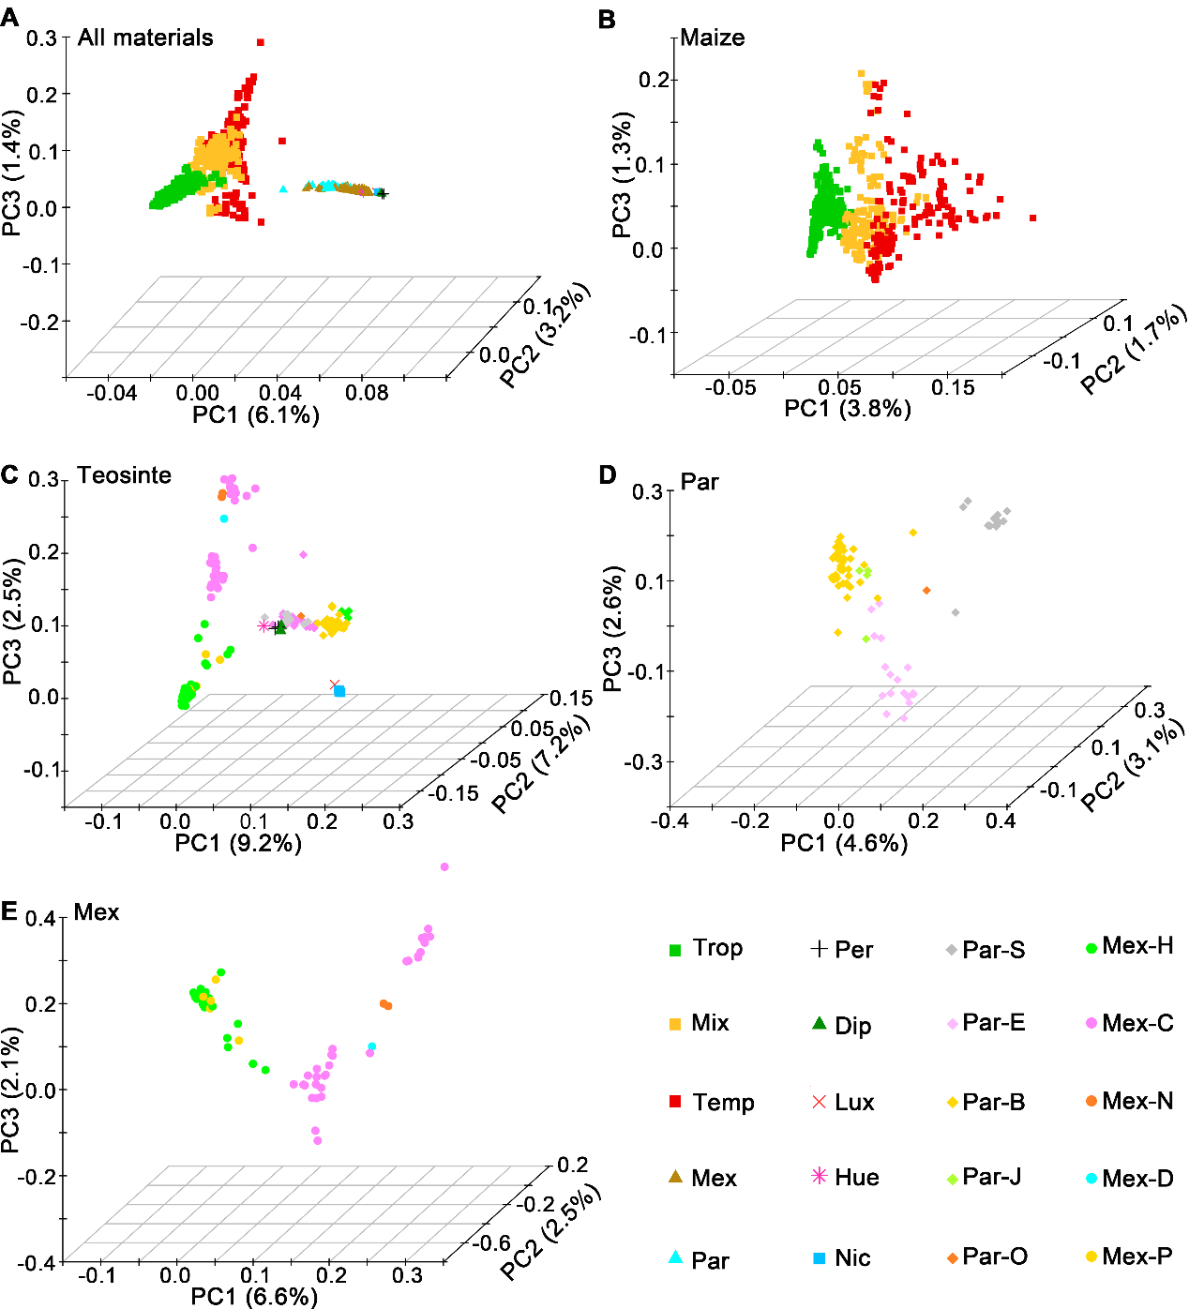
Figure S2 Genetic relationships of maize and teosinte assessed by PCA. (A) A PCA plot for all entries (982 maize lines and 190 teosinte accessions). (B−E) PCA plots for maize (B), teosinte (C), parviglumis (D) and mexicana (E). All entries are marked according to the inferred clusters from the ADMIXTURE analysis. Trop, tropical maize; Temp, temperate maize; Mix, maize lines with membership probabilities in both tropical and temperate groups of <0.70; Nic, nicaraguensis; Lux, luxurians; Dip, diploperennis; Per, perennis; Hue, huehuetenangsis; Mex, mexicana; Par, parviglumis. The parviglumis races: Par_S, Southern Guerrero; Par_E, Eastern Balsas; Par_O, Oaxaca; Par_B, Central Balsas; Par_J, Jalisco. The mexicana races: Mex_P, Puebla; Mex_C, Central Plateau; Mex_D, Durango; Mex_H, Chalco; Mex_N, Nobogame.

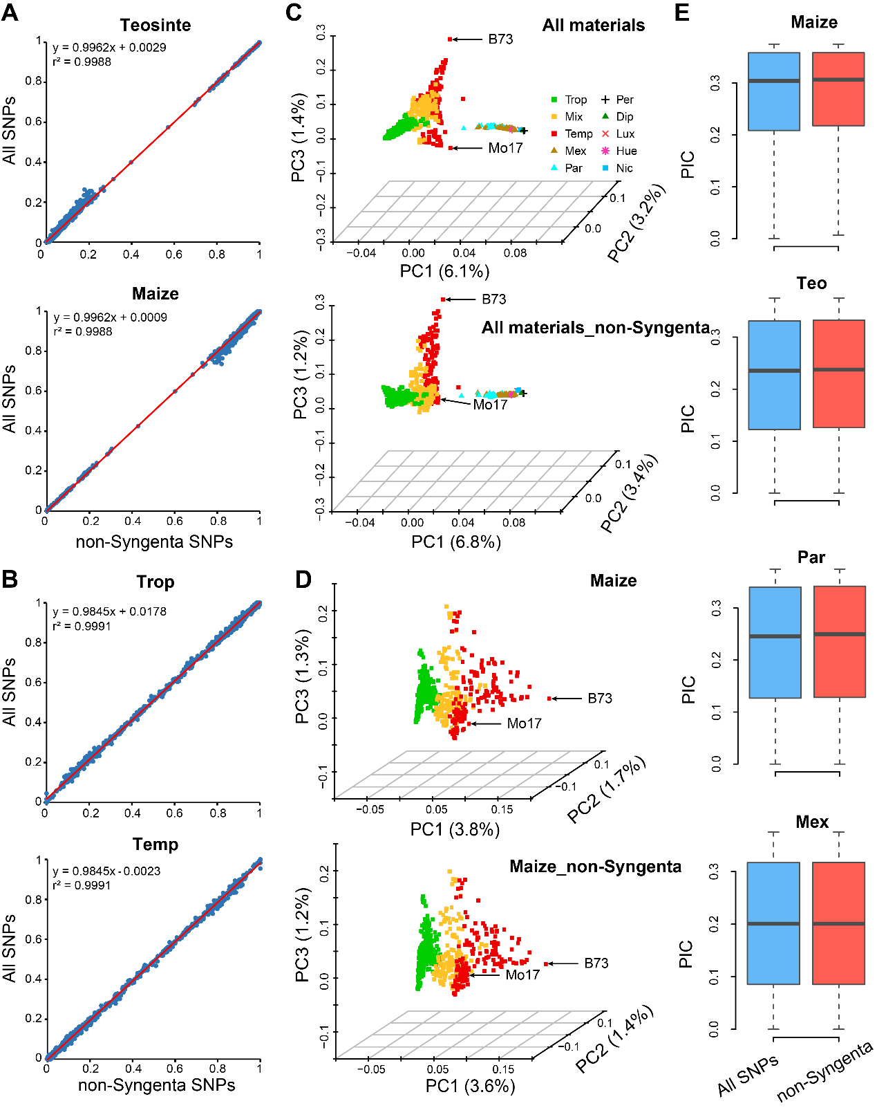
Figure S3 Evaluation of the ascertainment bias caused by Syngenta SNPs. (A-B) Correlation analysis of membership probabilities calculated by all SNPs and non-Syngenta SNPs in each assigned group. (C-D) PCA plots for all materials (C) and maize inbred lines (D) assessed using all SNPs (up panel) and non-Syngenta SNPs (down panel). (E) Distribution of polymorphic information content for all SNPs and non-Syngenta SNPs in each population. Trop, tropical maize; Temp, temperate maize; Par, parviglumis; Mex, mexicana.

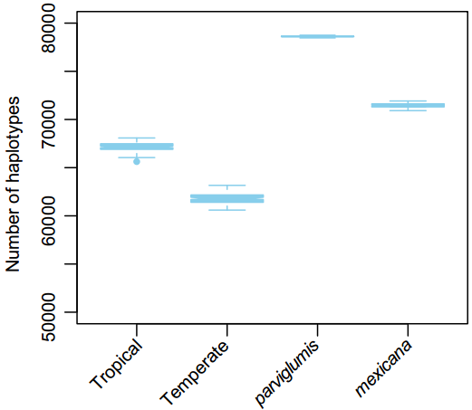
Figure S4 Haplotype richness in maize and teosinte groups estimated via the window-based method. A total of 75 samples were randomly selected from tropical maize, temperate maize, and mexicana accessions with 100 bootstraps.

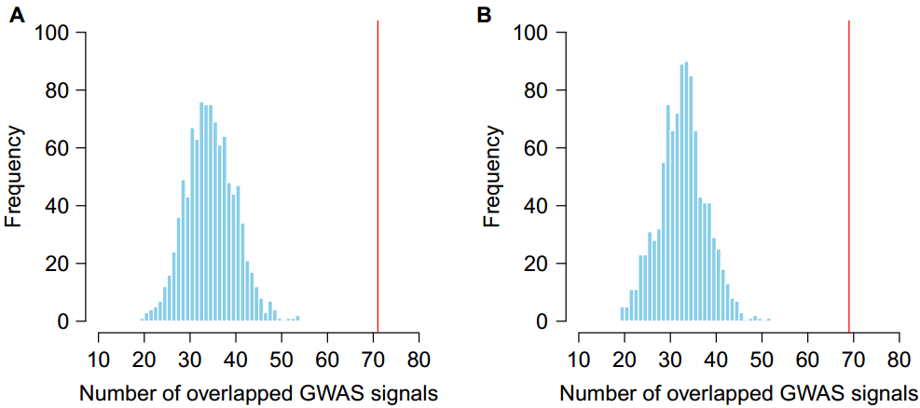
Figure S5 Co-localization of putative selective sweeps with public GWAS hits for flowering time. Counts of the public GWAS hits for flowering time [27, 39, 40] in the domestication (A) and adaptation (B) sweeps (red vertical lines) were compared with 1,000 permutations of controls (blue histogram).

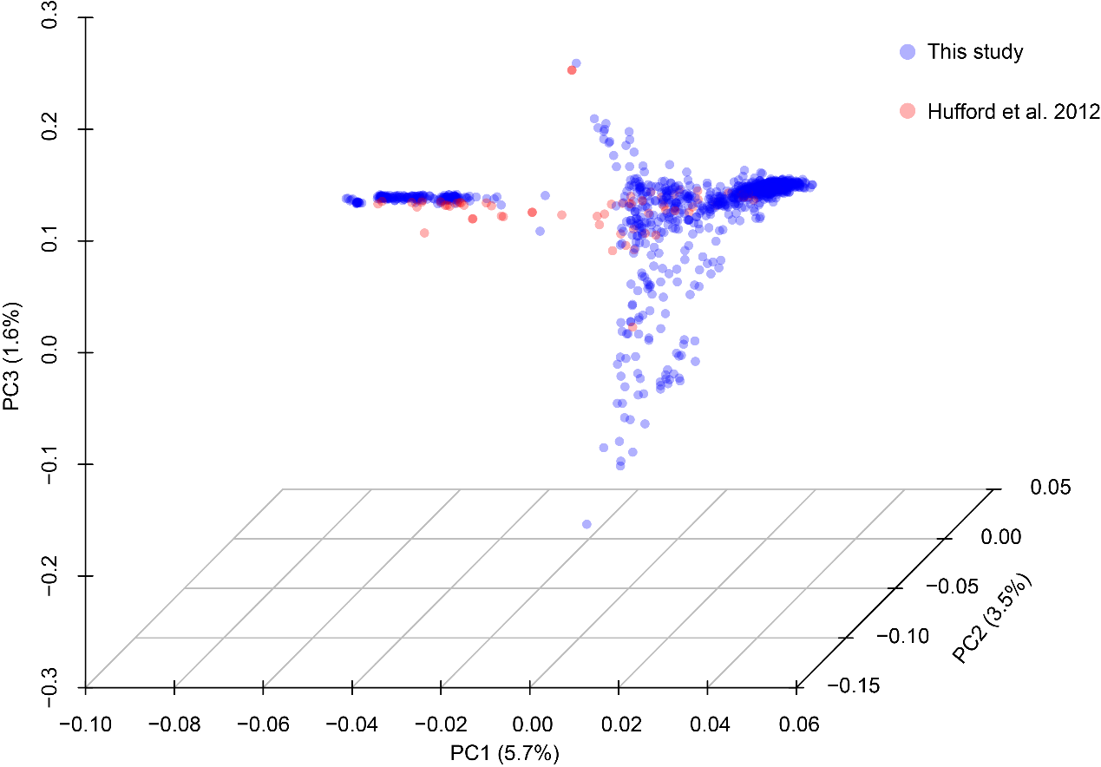
Figure S6 Genetic relationships of maize and teosinte assessed by PCA using 36,839 common SNPs between this study and Hufford et al.’s study [47]. The blue dots show the samples in this study, while the red dots show the samples in Hufford et al.’s study [47]. The PCA plot shows that the germplasms used in this study harbor greater genetic diversity than that in Hufford et al.’s study [47].

Table S1 Population divergence among maize and teosinte subgroups estimated by pairwise F_{ST} values between different groups
Subgroup | mexicana | parviglumis | Tropical maize
parviglumis | 0.10
Tropical maize | 0.19 | 0.17
Temperate maize | 0.21 | 0.19 | 0.12

Table S2 List of known domestication and adaptation genes in maize
Gene name | Gene ID_V3 | Chr | Pos.start.V3 | Pos.end.V3 | Selection Features | Reference
zagl1 | GRMZM2G026223 | 1 | 4855703 | 4871281 | Domestication | Zhao et al., 2011, Genet. Res., 93, 65-75; Wills et al., 2018, J. Hered., 109, 333-338
gt1 | GRMZM2G005624 | 1 | 23240104 | 23243489 | Domestication | Whipple et al., 2011, Proc. Natl. Acad. Sci. USA, 108, E506-512; Wills et al., 2013, PLoS Genet., 9, e1003604
zmm6 | GRMZM2G159397 | 1 | 194046502 | 194054589 | Domestication | Zhao et al., 2011, Genet. Res., 93, 65-75
ZmSh1-1 | GRMZM2G085873 | 1 | 260424101 | 260427079 | Domestication | Lin et al., 2012, Nat. Genet., 44, 720-724; Yang et al., 2016, Genetics, 204, 1573-1585
tb1 | AC233950.1_FG002 | 1 | 265811311 | 265813044 | Domestication | Studer et al., 2011, Nat. Genet., 43, 1160-1163
D8 | GRMZM2G144744 | 1 | 266160101 | 266163168 | Adaptation | Camus-Kulandaivelu et al., 2008, Genetics, 180, 1107-1121
ids1/Ts6 | GRMZM5G862109 | 1 | 292966682 | 292970925 | Domestication | Wang et al., 2019, New Phytol., 223, 1634-1646
pbf1 | GRMZM2G146283 | 2 | 154144472 | 154148029 | Domestication | Jaenicke-Després et al., 2003, Science, 302, 1206-1208
zag2 | GRMZM2G160687 | 3 | 137255997 | 137261748 | Domestication | Zhao et al., 2011, Genet. Res., 93, 65-75
tru1 | GRMZM2G039867 | 3 | 150088574 | 150091550 | Domestication | Dong et al., 2017, Proc. Natl. Acad. Sci. USA, 114, E8656-E8664
ZmMADS69 | GRMZM2G171650 | 3 | 159022119 | 159050063 | Domestication | Zhao et al., 2011, Genet. Res., 93, 65-75; Liang et al., 2019, New Phytol., 221, 2335-2347
su1 | GRMZM2G138060 | 4 | 41396390 | 41405179 | Domestication | Whitt et al., 2002, Proc. Natl. Acad. Sci. USA, 99, 12959-12962; Jaenicke-Després et al., 2003, Science, 302, 1206-1208
tga1 | GRMZM2G101511 | 4 | 44534815 | 44539478 | Domestication | Wang et al., 2005, Nature, 436, 714-719
bt2 | GRMZM2G068506 | 4 | 58979526 | 58985686 | Domestication | Whitt et al., 2002, Proc. Natl. Acad. Sci. USA, 99, 12959-12962
zmm19 | GRMZM2G370777 | 4 | 178918189 | 178925234 | Domestication | Zhao et al., 2011, Genet. Res., 93, 65-75
KRN4 | GRMZM2G460544 | 4 | 199456664 | 199460958 | Domestication | Liu et al., 2015, PLoS Genet., 11, e1005670
ZmSWEET4c | GRMZM2G137954 | 5 | 127500983 | 127504476 | Domestication | Sosso et al., 2015, Nat. Genet., 47, 1489-1493
ae1 | GRMZM2G032628 | 5 | 168492139 | 168509225 | Domestication | Whitt et al., 2002, Proc. Natl. Acad. Sci. USA, 99, 12959-12962
ZmMADS2 | GRMZM2G316366 | 5 | 177268178 | 177269968 | Domestication | Zhao et al., 2011, Genet. Res., 93, 65-75
zag1 | GRMZM2G052890 | 6 | 132008587 | 132016861 | Domestication | Zhao et al., 2011, Genet. Res., 93, 65-75
DXS2 | GRMZM2G493395 | 7 | 14086686 | 14089909 | Domestication | Fang et al., 2020, Plant J., 101, 278-292
ra1 | GRMZM2G003927 | 7 | 110359182 | 110359930 | Domestication | Sigmon and Vollbrecht, 2010, Mol. Ecol., 19, 1296-1311
zmm28 | GRMZM2G147716 | 7 | 164451097 | 164456819 | Domestication | Zhao et al., 2011, Genet. Res., 93, 65-75
ZCN8 | GRMZM2G179264 | 8 | 123030387 | 123032175 | Domestication and Adaptation | Guo et al., 2018, Curr. Biol., 28, 3005-3015 e3004
Vgt1/ ZmRap 2.7 | GRMZM2G700665 | 8 | 131576889 | 131580316 | Adaptation | Guo et al., 2018, Curr. Biol., 28, 3005-3015 e3004; Salvi et al., 2017, Proc. Natl. Acad. Sci. USA, 104, 11376-11381
zmm3 | AC197699.3_FG001 | 9 | 17021226 | 17024054 | Domestication | Zhao et al., 2011, Genet. Res., 93, 65-75
GL15 | GRMZM2G160730 | 9 | 96744684 | 96748035 | Domestication | Xu et al., 2017, Mol. Plant, 10, 1579-1583
ZmCCT9 | GRMZM2G004483 | 9 | 115786897 | 115789787 | Adaptation | Huang et al., 2018, Proc. Natl. Acad. Sci. USA, 115, E334-E341
ZmCCT10 | GRMZM2G381691 | 10 | 94262291 | 94264845 | Adaptation | Yang et al., 2013, Proc. Natl. Acad. Sci. USA, 110, 16969-16974

Table S3 Comparisons of selective sweeps identified in this study and previous studies, and the factors affecting the identification of selective sweeps
Studies | Approaches for selection scan | Sample size and used germplasms | SNP density | Reference genome | Sweep number
 |  |  |  |  | Domestication | Adaptation
This study | XP-CLR/ F_{ST} | 982 maize inbred lines, 171 teosinte accessions | 42,204 | Version 3 | 394 | 360
Hufford et al. 2012 [47] | XP-CLR | 35 improved maize lines, 23 landraces, 14 wild relatives | 21,141,953 | Version 2 | 484 | -
Liu et al. 2015 [45] | XP-CLR | 368 maize inbred lines | 558,529 | Version 2 | - | 695

