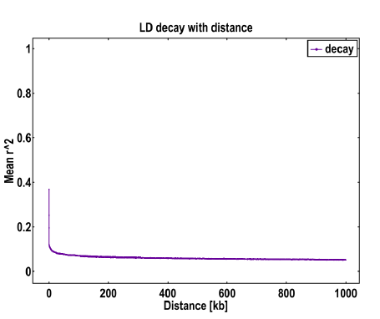
Fig. S2 Attenuation analysis of LD at the population level

