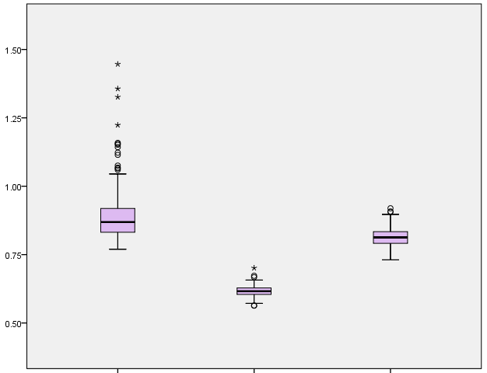
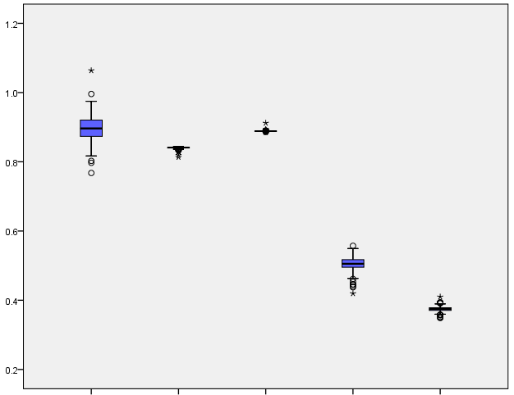
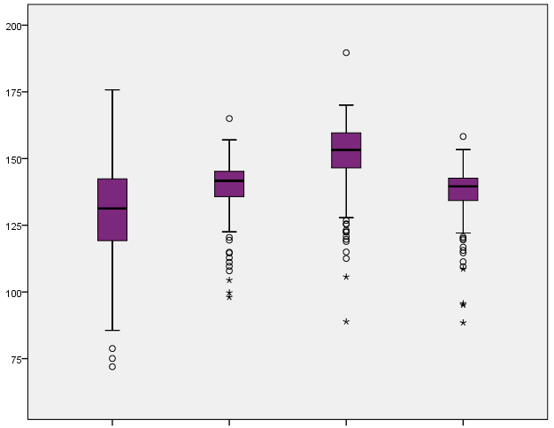
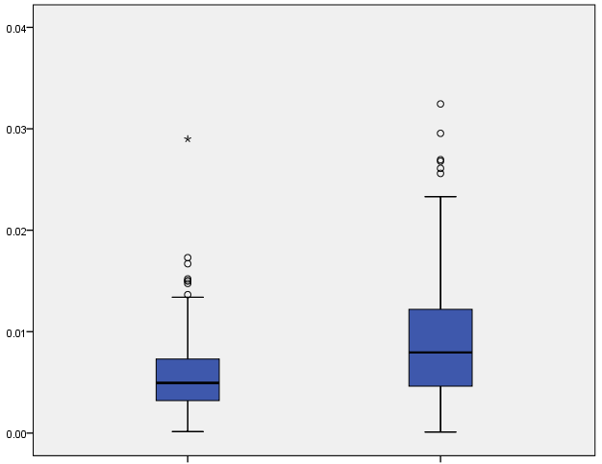
Proximal fruit blockiness
Distal fruit blockiness
Fruit shape triangle
Eccentricity
Proximal eccentricity
Distal eccentricity
Width widest pos
Eccentricity area index
Proximal angle micro
Proximal angle macro
Distal angle micro
Distal angle macro
Proximal indentation area
Shoulder height
Fig. S3 Distribution of the other morphological traits of grape berries

