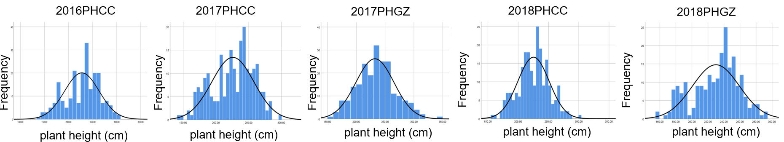
A

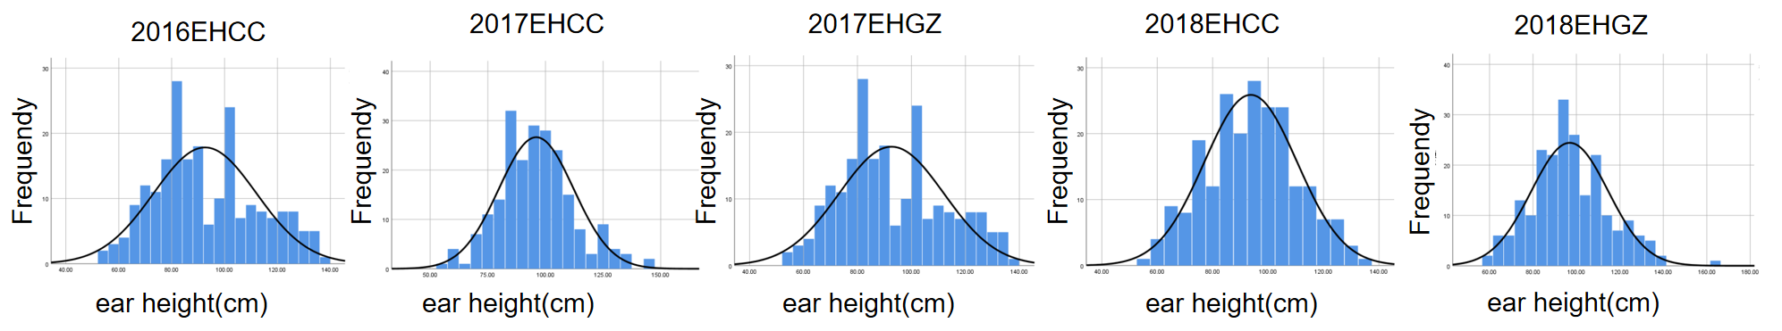

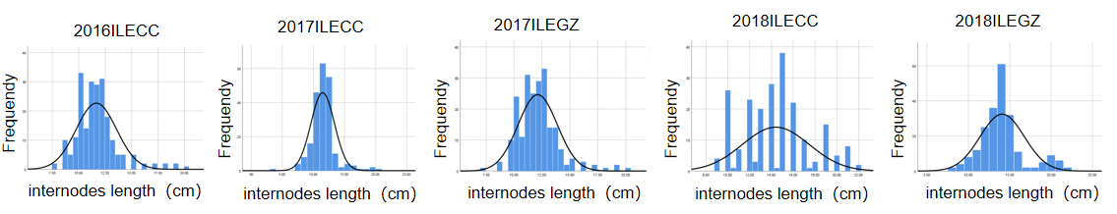

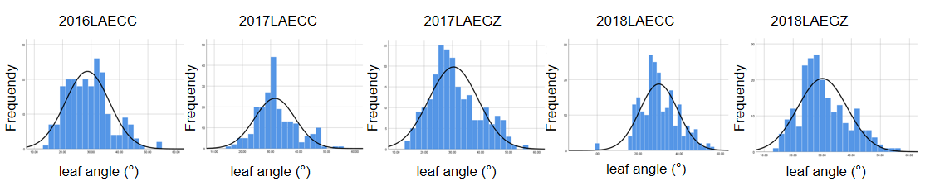

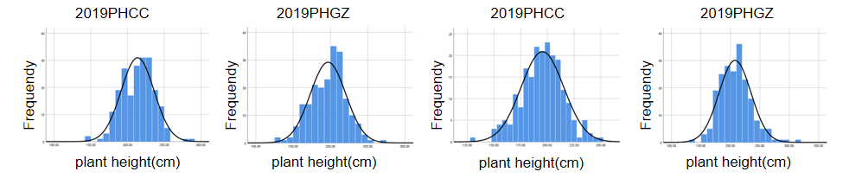
B

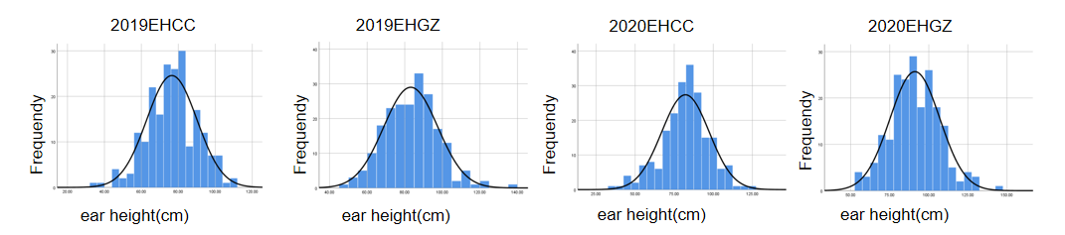

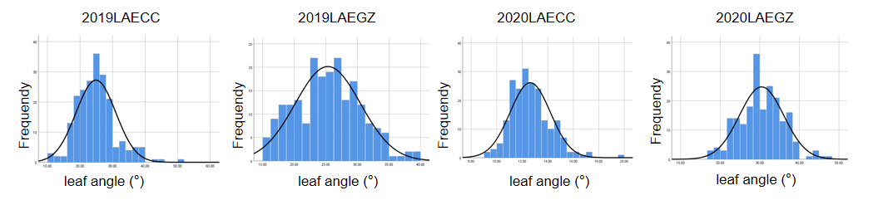

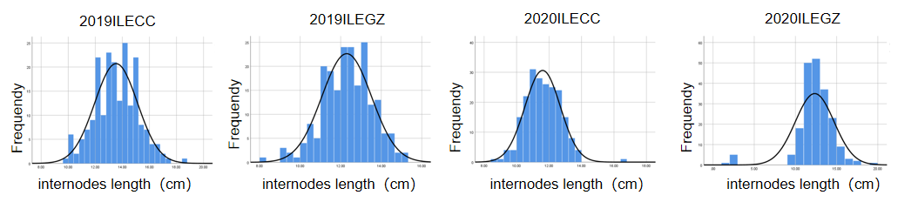 Figure S2: The frequency distribution of, the plant height (PH), ear height (EH) and leaf angle and internode length above the primary ear (LAE,ILE). (A) Frequency distribution in the F2:3 family population. (B) Frequency distribution in the recombinant inbred line population. CC, and GZ represent Changchun, and Gongzhuling, respectively.

