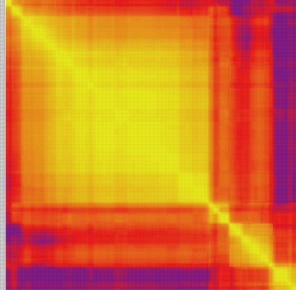
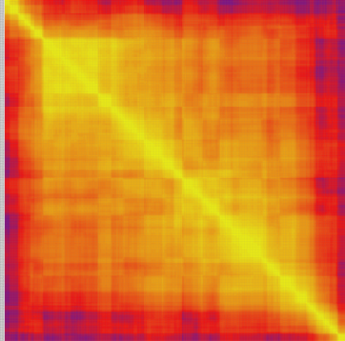
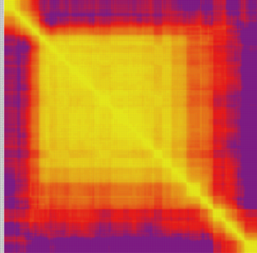
chromosome1
chromosome2
chromosome3

chromosome6
chromosome5
chromosome4

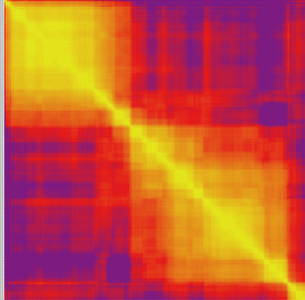
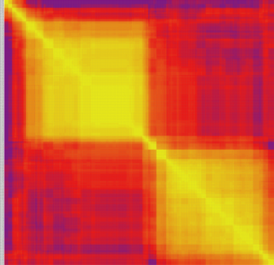
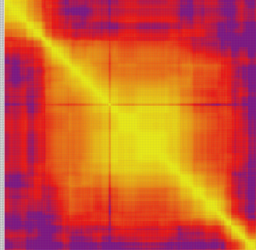

chromosome7
chromosome8
chromosome9

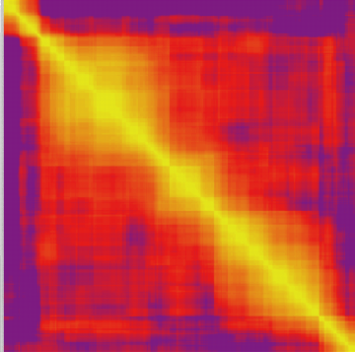
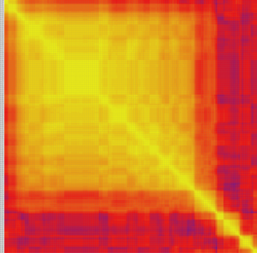
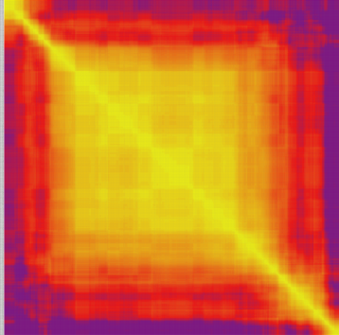

chromosome10
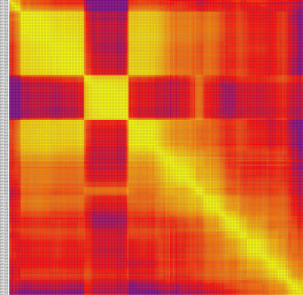

Figure S3 : Marker linkage relationship results on linkage group. Each row and each column are Markers arranged in the order of the map, and each small square represents the recombination rate between the two Markers. The change in color from yellow to red to purple represents the change in recombination rate from small to large. The closer the Marker's recombination rate is, the closer the color is to yellow, and the farther the Marker's recombination rate is, the closer it is to purple.

